Name: Jonathan Ko

**Table of Contents**

Project Direction Overview 2

Use Cases and Fields 5

Structural Database Rules 15

Conceptual Entity-relationship Diagram 17

Full DBMS Physical ERD 19

Stored Procedure Execution and Explanations 20

Quertion Identification Explanations 20

Query Executions and Explanations 20

Index Identification and Creations 20

Summary and Reflection 20

Appendix 22

# Project Direction Overview

I would like to develop an analytics platform leveraging NBA data to provide detailed insights and personalized recommendations for basketball enthusiasts. By combining NBA data with advanced analytics and machine learning techniques, this project aims to deliver valuable insights and personalized recommendations. The platform stores and processes player statistics, team performance data, historical game results, and advanced metrics. It also integrates various data sources, including official NBA statistics and player performance metrics, into a cohesive system for comprehensive analysis.

Key Features:

* Data Integration: Integrates official NBA statistics, player performance metrics, team data, salaries, game details, and injury reports into a unified database.
* Analytics and Insights: Provides detailed player performance analysis, team comparisons, historical game trends, and advanced metrics calculations to facilitate strategic decision making
* User Personalization: Offers personalized recommendations based on user preferences, historical data insights and real-time performance indicators.

Implementation Focus:

The project will focus on developing a scalable relational database architecture optimized for transactional data handling. Use cases include data entry for new games and player statistics, real-time updates for injuries, team management functionalities, and comprehensive reporting capabilities for stakeholders.

Motivation:

1. Comprehensive Data Analysis

Users can access and analyze a wide range of NBA data, including player statistics, team performance metrics, historical game results, and advanced analysis to gain deep insights into the performance and trends of their favorite players and teams.

1. Personalized Recommendations & Enhanced Decision Making

Users can leverage machine learning models to receive personalized recommendations advice for fantasy league participants and sports betting. This can range from which players to draft or trade, performance and predictive analysis which help improve their fantasy league performance game strategies and sports betting.

1. User Friendly Interface

Platform offers an intuitive and interactive interface for exploring NBA data and generating insights

1. Historical Analysis & Real-Time Updates

Platform will integrate with various data-sources to provide up-to-date information on player and team performance. Users can also explore historical data to study past performance and trends

1. Visualizations

Users can spot trends and compare performance metrics and understand key insights through graphs, charts or other visual tools.

Motivation:

The NBA Analytics Platform is motivated by the need for a comprehensive, user-friendly tool that enables basketball enthusiasts, team managers, and analysts to make informed decisions based on up-to-date and historical data. By integrating key data points such as player performance, team statistics, game results, and salary information, the platform aims to:

Enhance Decision-Making: Provide actionable insights through detailed analytics and visualizations, enabling users to make better decisions regarding player performance, team strategy, and financial management.

Facilitate Personalized Experiences: Offer tailored recommendations and predictions based on individual user preferences and historical data trends.

Support Strategic Planning: Assist team managers and analysts in understanding the impact of player performance and financial decisions on overall team success.

The platform’s focus on transactional data handling, real-time updates, and robust reporting ensures that users have the tools they need to gain valuable insights and stay ahead in the fast-paced world of basketball.

Use Case

USE CASE 1: John's Performance Analysis

Scenario: John logs into the platform and selects his favorite basketball player, LeBron James, to analyze his performance over the past season.

Actions:

* John accesses detailed game statistics for LeBron, including points, rebounds, assists, steals, and blocks.
* The platform retrieves historical data and displays visualizations showing performance trends, game-by-game breakdowns, and comparisons with other top players.
* John explores machine learning models available on the platform to predict LeBron’s future performance.

Outcome: John notices an improvement in LeBron’s shooting accuracy and decides to bet on his current hot streak.

Data Entry and Modification:

* Players' performance data is entered after each game, including points, rebounds, assists, steals, blocks, turnovers, free throw percentage, field goal percentage, and three-point shots.
* Modify player statistics if errors are found in the recorded data.

Lookups:

* Retrieve player performance data using playerID and gameID.
* Look up historical performance data of the player over different seasons.

Reports:

* Generate reports showing trends in player performance, such as average points per game, improvement in free throw percentage, etc.

Analytical Functions:

* Calculate the player's average statistics over a season.
* Compare the player's current season performance to previous seasons.

USE CASE 2: Sara's Team Management

Scenario: Sara is a team manager who needs to evaluate her team’s performance and manage player injuries.

Actions:

* Sara logs into the platform and reviews the team’s overall performance metrics, including win-loss records, player statistics, and recent game results.
* She accesses the injury report to check the status of key players and assess how injuries might impact upcoming games.
* Sara uses the platform’s reporting features to generate a performance report and strategize player rotations and game plans.

Outcome: Sara uses the insights to make informed decisions about team strategy and player management.

Data Entry and Modification:

* Enter team performance data after each game, including total points, rebounds, assists, steals, blocks, turnovers, free throw percentage, field goal percentage, and three-point shots.
* Update team statistics if errors are found.

Lookups:

* Retrieve team performance data using teamID and gameID.
* Look up historical performance data of the team over different seasons.

Reports:

* Generate reports comparing team performance against different opponents.
* Reports showing team’s performance trends over the season.

Analytical Functions:

* Calculate the team’s average performance metrics over a season.
* Compare the team’s performance in home vs. away games.

USE CASE 3: David’s Injury Impact Analysis

Scenario: David is a sports analyst tasked with evaluating how recent injuries have impacted the performance of a specific player and the team’s overall success.

Actions:

* David logs into the platform and accesses the injury report for the player in question.
* He retrieves historical performance data for the player before and after the injury.
* The platform provides tools to analyze changes in the player's statistics, such as average points, assists, and rebounds, along with team performance metrics during the injury period.
* David generates a detailed impact analysis report showing how the player’s absence affected team performance and identifies potential areas for improvement.

Outcome: David uses the insights to provide recommendations on how the team can adapt to injuries and prepare for future games, helping to minimize the negative impact of player absences.

Data Entry and Modification:

* Record injury details when a player gets injured, including injury type, start date, expected recovery time, and status.
* Update injury status and recovery details as the player progresses.

Lookups:

* Retrieve injury records using playerID and injuryID.
* Look up player performance before and after injuries.

Reports:

* Generate reports showing the impact of injuries on player performance.
* Reports showing the team’s performance with and without injured players.

Analytical Functions:

* Compare player’s performance metrics before and after injuries.
* Calculate the average recovery time for different types of injuries.

USE CASE 4: Emma’s Game Comparison

Scenario: Emma is a basketball enthusiast who wants to compare the performance of two teams during a specific season to understand their relative strengths.

Actions:

* Emma logs into the platform and selects the two teams she wants to compare.
* She specifies the season and filters the data to include key metrics such as points scored, defensive stats, turnovers, and field goal percentages.
* The platform generates a comparative report and visualizations that highlight performance differences, trends, and statistical outliers for each team.
* Emma reviews the side-by-side comparison and identifies which team had the stronger overall performance and where each team’s strengths and weaknesses lie.

Outcome: Emma uses the comparison to enhance her understanding of team dynamics and to engage more deeply with game analyses and discussions.

Data Entry and Modification:

* Enter game details including date, home team, away team, and scores.
* Update game details if any corrections are needed.

Lookups:

* Retrieve game details using gameID.
* Look up team performance in specific games.

Reports:

* Generate comparative reports for team performance in different games.
* Reports comparing the performance of home team vs. away team.

Analytical Functions:

* Calculate average scores for home and away games.
* Compare performance metrics of teams against different opponents.

USE CASE 5: Mike's Salary and Cap Space Analysis:

Scenario: Mike is a sports analyst interested in understanding team salary cap space and player salaries.

Actions:

* Mike logs into the platform and navigates to the salary and cap space section.
* He reviews detailed salary information for each player and analyzes how it affects the team’s cap space and future financial flexibility.

Outcome: Mike uses the analysis to provide clear understanding of player’s salaries, contract durations, and the team’s salary cap

Data Entry and Modification:

* Enter contract details including playerID, teamID, contract start and end dates, and annual salary.
* Update contract details if there are any changes.

Lookups:

* Retrieve contract details using playerID and teamID.
* Look up salary cap details for specific seasons.

Reports:

* Generate reports showing current salaries of players in a team.
* Reports indicating whether a team is above the salary cap, first apron, or second apron.

Analytical Functions:

* Calculate total team salary and compare it with the salary cap.
* Determine the remaining time on each player’s current contract.

# Use Cases and Fields

Use Case 1: Player Performance Analysis

Steps:

User selects a player from the platform's interface.

Platform retrieves player data from the database.

Platform processes and visualizes player performance metrics over a specified period.

User views detailed statistics, including points, rebounds, assists, steals, and blocks.

User compares the player's performance with other players or against historical data

|  |  |  |
| --- | --- | --- |
| Player Performance Analysis | | |
| Players Table | | |
| Field | What it stores | Why its needed |
| playerID | unique identifier for each player | to uniquely distinguish players and link their data across different tables |
| playerName | full name of player | for displaying player name and linking their data across different tables |
| teamID | identifier for the team the player is on | to link players with their respective teams and retrieve team-related data |
| position | position the player plays for | for analysis on player position based and specific role-based performance metric |
| Player Stats Table | | |
| Field | What it stores | Why its needed |
| playerID | unique identifier for each player | to link players statistics to the specific player |
| gameID | identifier for the game in which the player participated | to link player performance to specific games |
| points | number of points scored by the player in the game | for calculating scoring performance and trends |
| rebounds | number of rebounds made by the player | for assessing the player's defensive and offensive capabilities |
| assists | number of assists made by the player | to evaluate the player's playmaking ability |
| steals | number of steals made by the player | for defensive performance analysis |
| blocks | number of blocks made by the player | for defensive performance analysis |
| turnovers | number of turnovers made by the player | for assessing the player's offensive deficiencies |
| ft% | percentage of ft made by the player | for calculating scoring efficiency |
| fg% | percentage of field goals made by the player | for calculating scoring efficiency |
| 3pts | number of 3pointers made by the player | for calculating scoring performance and trends |
| Games Table | | |
| Field | What it stores | Why its needed |
| gameID | unique identifier for each game | to distinguish and retrieve specific game data |
| date | the date on which the game was played | for chronological analysis and tracking performance over time |

Use Case 2: Team Performance Analysis

Steps:

User selects a team from the platform's interface.

Platform retrieves team data from the database.

Platform processes and visualizes team performance metrics over a specified period.

User views team statistics, including wins/losses, scoring averages, and defensive metrics.

User compares the team's performance against other teams or across different seasons.

|  |  |  |
| --- | --- | --- |
| Team Performance Analysis | | |
| Teams Table | | |
| Field | What it stores | Why its needed |
| teamID | unique identifier for each player | to uniquely identify and link teams across various tables |
| teamName | Name of the team | For displaying team information and for user selection |
| conferenceID | Identifier for the conference to which the team belongs. | Used for grouping teams and comparing performance within conferences. |
| divisionID | Identifier for the division within the conference to which the team belongs. | Facilitates divisional analysis and comparison of teams' performances within the same division. |
| Teams Stats Table | | |
| Field | What it stores | Why its needed |
| teamID | unique identifier for the team | to link team statistics to the specific team |
| gameID | identifier for the game in which the team played | to link team performance to specific games |
| points | total points made by the team | for scoring analysis and comparison |
| rebounds | total rebounds made by the team | to assess the team's defensive and offensive performance |
| assists | total assists made by the team | to evaluate team playmaking ability |
| steals | total steals made by the team | for defensive performance analysis |
| blocks | total blocks made by the team | to measure the team's defensive impact |
| turnovers | total turnovers made by the team | for assessing the teams offensive deficiencies |
| ft% | total freethrow percentage made by the team | for calculating scoring efficiency |
| fg% | total field goal percentage made by the team | for calculating scoring efficiency |
| 3pts | total 3 pointers made by the team | for calculating scoring performance and trends |
| Games Table | | |
| Field | What it stores | Why its needed |
| gameID | unique identifier for each game | to distinguish and retrieve specific game data |
| date | the date on which the game was played | for chronological analysis and tracking performance over time |
| hometeamID | identifier for the home team | to link and analyze home team performance |
| awayteamID | identifier for the away team | to link and analyze away team performance |
| home_score | points scored by the home team | for analyzing game outcomes and home team advantage |
| away_score | points scored by the away team | for analyzing game outcomes and away team advantage |

Use Case 3: Injury Impact Analysis

Steps:

User login and retrieves player’s injury status from Injuries table using Player ID

User identifies injuries by injuryID and analyzes details such as injuryType, startDate, endDate, status

User selects player using PlayerID and accesses their performance data from Player stats table before and after injury

User can analyze all metrics and track recovery progress by viewing current status and timeline

User generates impact report

|  |  |  |
| --- | --- | --- |
| Injury Impact Analysis | | |
| Players Table | | |
| Field | What it stores | Why its needed |
| playerID | Unique identifier for each player | To uniquely distinguish players and link their data across different tables. |
| playerName | Full name of player | for displaying player name and linking their data across different tables |
| teamID | identifier for the team the player is on | to link players with their respective teams and retrieve team-related data |
| position | position the player plays for | for analysis on player position based and specific role-based performance metric |
| Player Stats Table | | |
| Field | What it stores | Why its needed |
| playerID | Unique identifier for each player | to link players statistics to the specific player |
| gameID | Identifier for the game in which the player participated. | To link player performance to specific games. |
| points | Number of points scored by the player in the game. | For calculating scoring performance and trends. |
| rebounds | Number of rebounds made by the player. | For assessing the player's defensive and offensive capabilities |
| assists | Number of assists made by the player. | To evaluate the player's playmaking ability |
| steals | Number of steals made by the player. | For defensive performance analysis. |
| blocks | Number of blocks made by the player. | For defensive performance analysis. |
| turnovers | Number of turnovers made by the player. | For assessing the player's offensive deficiencies |
| ft% | percentage of ft made by the player. | For calculating scoring efficiency |
| fg% | percentage of field goals made by the player. | For calculating scoring efficiency |
| 3pts | Number of 3pointers made by the player. | For calculating scoring performance and trends. |
| Games Table | | |
| Field | What it stores | Why its needed |
| gameID | Unique identifier for each game. | To distinguish and retrieve specific game data. |
| date | The date on which the game was played | For chronological analysis and tracking performance over time. |
| Injuries Table | | |
| Field | What it stores | Why its needed |
| playerID | Unique identifier for each player | to link players statistics to the specific player |
| injuryID | Unique identifier for each injury record | To uniquely distinguish between different injury records |
| gameID | Unique identifier for each game. | To distinguish and retrieve specific game data. |
| injuryType | The date on which the game was played | For chronological analysis and tracking performance over time. |
| startDate | Date when the injury was first recorded | To track when the injury began |
| endDate | Date when the injury was resolved or expected to resolve | To track the duration of the injury |
| status | Current status of the injury (e.g., day-to-day, out, questionable) | To provide real-time information on player availability |
| recoverytime | estimated recovery time for injury | to manage expectations and plan player's return |
| Recovery Table | | |
| Field | What it stores | Why its needed |
| recoveryID | unique identifier for each recovery record | to uniquely identify and track recovery record |
| injuryID | identifier linking to the specific injury | to associate recovery data with associated injury |
| stateDate | date when recovery started | to track recovery timeline |
| endDate | date when recovery ended | to measure duration and success of recovery |
| status | current status of recovery | for tracking and updating recovery progress |

Use Case 4: Game Comparison

Steps:

User logs into platform and selects the player using playerID from Player’s Table

User retrieves performance data for the player from the table Player Stats Table using playerID and various gameIDs

User compares metrics across games

Platform generates averages and possible trends

User gains valuable information on player performance consistency and identifies patterns.

|  |  |  |  |  |  |
| --- | --- | --- | --- | --- | --- |
| Game Comparison | | | | | |
| Games Table | | | | | |
| Field | What it stores | | Why its needed | | |
| gameID | unique identifier for each game | | to distinguish and retrieve specific game data | | |
| date | the date on which the game was played | | for chronological analysis and tracking performance over time | | |
| hometeamID | identifier for the home team | | to link and analyze home team performance | | |
| awayteamID | identifier for the away team | | to link and analyze away team performance | | |
| home_score | points scored by the home team | | for analyzing game outcomes and home team advantage | | |
| away_score | points scored by the away team | | for analyzing game outcomes and away team advantage | | |
| Player Stats Table | | | | | |
| Field | What it stores | | Why its needed | | |
| playerID | unique identifier for each player | | to link players statistics to the specific player | | |
| gameID | identifier for the game in which the player participated | | to link player performance to specific games | | |
| points | number of points scored by the player in the game | | for calculating scoring performance and trends | | |
| rebounds | number of rebounds made by the player | | for assessing the player's defensive and offensive capabilities | | |
| assists | number of assists made by the player | | to evaluate the player's playmaking ability | | |
| steals | number of steals made by the player | | for defensive performance analysis | | |
| blocks | number of blocks made by the player | | for defensive performance analysis | | |
| turnovers | number of turnovers made by the player | | for assessing the player's offensive deficiencies | | |
| ft% | percentage of ft made by the player | | for calculating scoring efficiency | | |
| fg% | percentage of field goals made by the player | | for calculating scoring efficiency | | |
| 3pts | number of 3pointers made by the player. | | for calculating scoring performance and trends | | |
| Teams Stats Table | | | | |
| Field | | What it stores | | Why its needed |
| teamID | | Unique identifier for the team. | | To link team statistics to the specific team |
| gameID | | Identifier for the game in which the team played. | | To link team performance to specific games |
| points | | Total points made by the team | | For scoring analysis and comparison. |
| rebounds | | Total rebounds made by the team | | To assess the team's defensive and offensive performance |
| assists | | Total assists made by the team | | To evaluate team playmaking ability |
| steals | | Total steals made by the team | | For defensive performance analysis |
| blocks | | Total blocks made by the team | | To measure the team's defensive impact |
| turnovers | | Total turnovers made by the team | | For assessing the teams offensive deficiencies |
| ft% | | Total freethrow percentage made by the team | | For calculating scoring efficiency |
| fg% | | Total field goal percentage made by the team | | For calculating scoring efficiency |
| 3pts | | Total 3 pointers made by the team | | For calculating scoring performance and trends. |

Use case 5: Salary Cap Management and Analysis

The user logs into the platform and navigates to the team's salary page.

The user retrieves the current salary and contract details for each player from the Player Contracts Table using teamID.

The user views the list of players, including playerName, annualSalary, contractStart, and contractEnd.

The user checks the team's overall salary status from the Team Salary Table using teamID.

The platform displays whether the team is above the salary cap, first apron, or second apron based on totalSalary, salaryCap, firstApron, and secondApron.

The user sees clear indicators of the team's salary cap situation and the remaining time on each player's contract.

|  |  |  |
| --- | --- | --- |
| Salary Cap Management and Analysis | | |
| Player's Contract Table | | |
| Field | What it Stores | Why it's Needed |
| playerID | Unique identifier for the player | To link the contract record to a specific player |
| teamID | Unique identifier for the team | To link the contract to a specific team |
| playerName | Name of the player | To display player information |
| contractStart | Date when the contract starts | To track the contract duration |
| contractEnd | Date when the contract ends | To track the contract duration |
| annualSalary | Annual salary of the player | To calculate total team payroll |
| Team Salary Table | | |
| Field | What it Stores | Why it's Needed |
| teamID | Unique identifier for the team | To link the salary data to a specific team |
| season | The NBA season | To analyze payroll for a specific season |
| totalSalary | Total salary paid by the team | To calculate cap space and determine salary cap status |
| salaryCap | The salary cap for the season | To compare team salary against the cap |
| firstApron | The first apron threshold | To determine if the team is above the first apron |
| secondApron | The second apron threshold | To determine if the team is above the second apron |

# Structural Database Rules

#### Entities:

1. **Player**
2. Team
3. **Contract**
   1. Relationship: Disjoint (a contract cannot be more than one type simultaneously) and Complete (a contract must be one of these types)
   2. A contract can be a rookie contract, veteran contract, max contract, or free agent contract
4. **Season**
5. **SalaryCap**
6. **Game**
   1. **Relationship: Disjoint (a game cannot be more than one type simultaneously) and Complete (a game must be classified as one of these types)**
   2. A game can be a regular season game, playoff game, or exhibition game
7. **PlayerStats**
8. **TeamStats**
9. **Injury**
   1. Relationship: Disjoint (an injury cannot be both minor and major simultaneously) and Complete (an injury must be classified as either minor or major)
   2. An injury must be classified as either minor or major and cannot be both simultaneously.
10. **Recovery**

#### Constraints:

1. Player:
   * playerID is the primary key and must be unique.
   * playerName cannot be null.
   * teamID is a foreign key linking to the Team table.
   * position cannot be null.
2. Team:
   * teamID is the primary key and must be unique.
   * teamName cannot be null.
   * conferenceID a foreign key linking to the Conference table.
   * divisionID a foreign key linking to the Division table.
3. Contract (supertype):
   * contractID is the primary key and must be unique.
   * playerID is a foreign key linking to the Player table.
   * teamID is a foreign key linking to the Team table.
   * contractStart cannot be null.
   * contractEnd cannot be null.
   * annualSalary cannot be null.
4. RookieContract (subtype of Contract)
   * contractID is the primary key and must be unique.
   * contractID is a foreign key linking to the Contract table.
   * rookieScale cannot be null
5. VeteransContract (subtype of Contract)
   * contractID is the primary key and must be unique.
   * contractID is a foreign key linking to the Contract table.
   * veteranBonus cannot be null
6. MaxContract (subtype of Contract)
   * contractID is the primary key and must be unique.
   * contractID is a foreign key linking to the Contract table.
   * maxAmount cannot be null
7. FreeAgentContract (subtype of Contract)
   * contractID is the primary key and must be unique.
   * contractID is a foreign key linking to the Contract table.
   * freeAgentBonus cannot be null
8. Season:
   * seasonID is the primary key and must be unique.
   * seasonYear cannot be null.
   * startDate cannot be null.
   * endDate cannot be null.
9. SalaryCap:
   * capID is the primary key and must be unique.
   * seasonID is a foreign key linking to the Season table.
   * salaryCap cannot be null.
   * firstApron cannot be null.
   * secondApron cannot be null.
10. Game (supertype):
    * gameID is the primary key and must be unique.
    * date cannot be null.
    * hometeamID is a foreign key linking to the Team table.
    * awayteamID is a foreign key linking to the Team table.
    * home_score cannot be null.
    * away_score cannot be null.
11. RegularSeasonGame (subtype of Game)
    * gameID is the primary key and must be unique.
    * gameID is a foreign key linking to the Game table.
12. PlayoffGame (subtype of Game)
    * gameID is the primary key and must be unique.
    * gameID is a foreign key linking to the Game table.
13. ExhibitionGame (subtype of Game)
    * gameID is the primary key and must be unique.
    * gameID is a foreign key linking to the Game table.
14. PlayerStats:
    * playerID is a foreign key linking to the Player table.
    * gameID is a foreign key linking to the Game table.
    * points, rebounds, assists, steals, blocks, turnovers, ft%, fg%, 3pts cannot be null.
    * Composite primary key (playerID, gameID).
15. TeamStats:
    * teamID is a foreign key linking to the Team table.
    * gameID is a foreign key linking to the Game table.
    * points, rebounds, assists, steals, blocks, turnovers, ft%, fg%, 3pts cannot be null.
    * Composite primary key (teamID, gameID).
16. Injury (supertype):
    * injuryID is the primary key and must be unique.
    * playerID is a foreign key linking to the Player table.
    * gameID is a foreign key linking to the Game table.
    * injuryType cannot be null.
    * startDate cannot be null.
    * endDate can be null.
    * status cannot be null.
    * recoveryTime cannot be null.
17. MinorInjury (subtype of Injury):
    * injuryID is the primary key and must be unique.
    * injuryID is a foreign key linking to the Injury table.
    * minorSeverity cannot be null.
18. MajorInjury (subtype of Injury):
    * injuryID is the primary key and must be unique.
    * injuryID is a foreign key linking to the Injury table.
    * majorSeverity cannot be null.
19. Recovery:
    * recoveryID is the primary key and must be unique.
    * injuryID is a foreign key linking to the Injury table.
    * startDate cannot be null.
    * endDate can be null.
    * status cannot be null.

# Conceptual Entity-Relationship Diagram

#### Relationships:

1. Each team has many players; each player belongs to one team.
2. Each player has one contract per team; each contract is associated with one player
3. Each team participates in many seasons; each season involves many teams
4. Each season has one salary cap; each salary cap is associated with one season
5. Each player participates in many games; each game involves many players
6. Each team participates in many games; each game involves two teams
7. Each player has many injuries; each injury is associated with one player
8. Each injury has one recovery; each recovery is associated with one injury
9. Each player has many player stats entries, each associated with different games
10. Each game has many player stats entries, one for each player participating in the game
11. Each team has many team stats entries, each associated with different games
12. Each game has many team stats entries, one for each team participating in the game

#### UML Class Diagram Relationships:

1. **Team has many Players**
   * **Team 1 ------------------- * Player**
   * **Association: teamID**
2. **Player has one Contract per Team**
   * **Player 1 ------------------- 1 Contract**
   * **Association: playerID, teamID**
3. **Team participates in many Seasons**
   * **Team * ------------------- * Season**
   * **Association: teamID, seasonID**
4. **Season has one SalaryCap**
   * **Season 1 ------------------- 1 SalaryCap**
   * **Association: seasonID**
5. **Player participates in many Games**
   * **Player * ------------------- * Game**
   * **Association: playerID, gameID**
6. **Team participates in many Games**
   * **Team * ------------------- * Game**
   * **Association: teamID, gameID**
7. **Player has many Injuries**
   * **Player 1 ------------------- * Injury**
   * **Association: playerID**
8. **Injury has one Recovery**
   * **Injury 1 ------------------- 1 Recovery**
   * **Association: injuryID**
9. **Player - PlayerStats**
   * **Player 1 ------------------- * PlayerStats**
   * **Association: playerID**
10. **Game - PlayerStats**
    * **Game 1 ------------------- * PlayerStats**
    * **Association: gameID**
11. **Team - TeamStats**
    * **Team 1 ------------------- * TeamStats**
    * **Association: teamID**
12. **Game - TeamStats**
    * **Game 1 ------------------- * TeamStats**
    * **Association: gameID**

#### Supporting Explanations:

* Player: Represents individual players, with attributes capturing personal and team-related details. Relationships define the connections to contracts, teams, games, player statistics, and injuries.
* Team: Represents teams, capturing key details such as team name, and relationships to conference and division. Relationships define the connections to players, seasons, games, and team statistics.
* Contract: A supertype entity representing contracts with subtypes for different types of contracts (rookie, veteran, max, free agent). Each contract is associated with one player and one team.
* Season: Represents different seasons, with attributes for the year, start date, and end date. Each season has a salary cap and involves multiple teams.
* SalaryCap: Represents the salary cap for a particular season, with attributes for the cap amount and aprons.
* Game: A supertype entity representing games with subtypes for different types of games (regular season, playoff, exhibition). Each game involves multiple players and teams and is associated with player and team statistics.
* PlayerStats: Represents individual player statistics for each game, capturing performance metrics. Each player stat entry is linked to one player and one game.
* TeamStats: Represents team statistics for each game, capturing overall team performance metrics. Each team stat entry is linked to one team and one game.
* Injury: Represents injuries sustained by players, capturing details about the injury and its impact. Each injury is linked to one player and one game and is associated with a recovery record.
* Recovery: Represents the recovery process for injuries, capturing details about the start and end of the - recovery period. Each recovery is linked to one injury.

# Full DBMS Physical ERD

#### Normalizing Entities:

Initial Analysis:

* PlayerStats and TeamStats: These tables already use composite keys (playerID, gameID for PlayerStats and teamID, gameID for TeamStats) to ensure that each record is unique and represents statistics for a specific player or team in a specific game. No further normalization is required, as these composite keys prevent redundancy
* Injury and Recovery: The design of the Injury and Recovery tables ensures that each recovery is associated with a specific injury, which prevents redundancy. Each Recovery record is uniquely tied to an Injury, and any updates to injury status or recovery details are managed within these tables, avoiding redundancy.
* Contract and TeamSeason: The Contract and TeamSeason tables are already designed to avoid redundancy, with Contract detailing specific contract types and TeamSeason managing the association of teams with specific seasons. Each table maintains unique records without repetition of data.

**Normalization of Conference and Division**

* **Issue: The Team table includes conference and division attributes, which can lead to repeating values across multiple records. This repetition can increase the size of the database and make it more difficult to maintain data integrity, especially if a conference or division name changes.**
* **Fix: To eliminate redundancy, we normalize the conference and division attributes by creating separate tables for each entity. The Team table will then reference these tables using foreign keys, ensuring that each conference and division is only recorded once in the database.**
  + **Conference Table:**
    - **Fields: conferenceID (Primary Key), conferenceName.**
    - **Stores unique records for each conference**
  + **Division Table:**
    - **Fields: divisionID (Primary Key), divisionName, conferenceID (Foreign Key).**
    - **Stores unique records for each division and links each division to a specific conference.**
  + **Team Table:**
    - **Updated to include foreign keys conferenceID and divisionID, which reference the Conference and Division tables, respectively.**

Explanation of Choices

* Normalization to 3NF: The normalization of the Conference and Division attributes ensures that the Team table adheres to the Third Normal Form (3NF). This process eliminates redundant data and maintains data integrity by ensuring that each attribute is atomic and that there are no transitive dependencies.
* Data Integrity: The use of separate tables for Conference and Division ensures that these attributes are stored consistently across the database. Any change to a conference or division name only needs to be made in one place, reducing the risk of data inconsistencies.
* Maintenance: By normalizing these attributes, the database becomes easier to maintain. The relationships between teams, conferences, and divisions are clearly defined, and the data model is simplified by avoiding unnecessary repetition.
* Query Performance: Normalization can also improve query performance by reducing the size of the Team table and making it easier to index and search for records based on conference and division.



# Stored Procedure Execution and Explanations

1. Procedure to Add a New Player

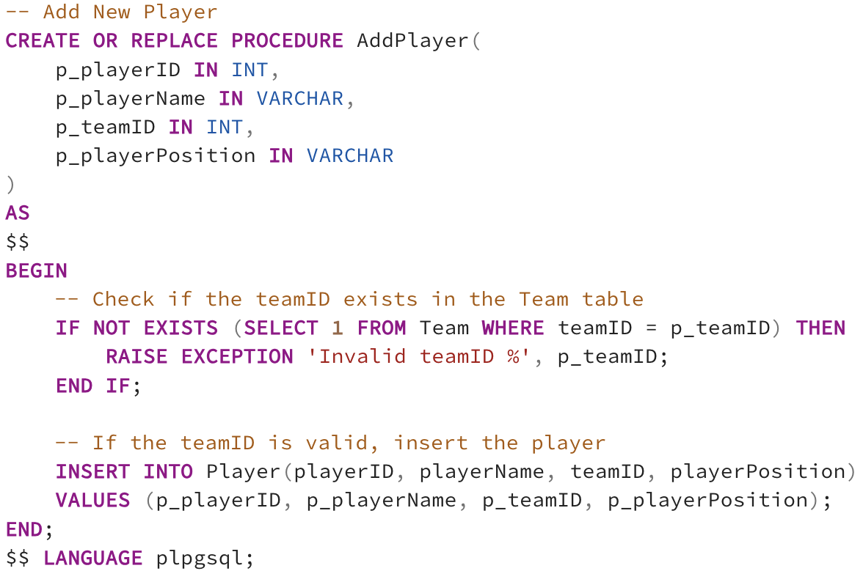

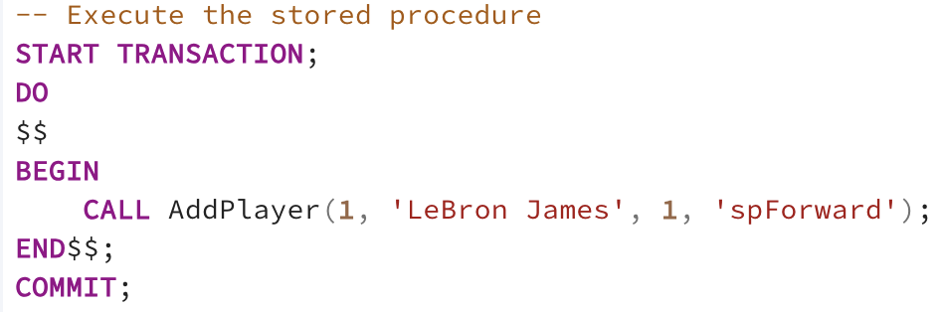

Example:

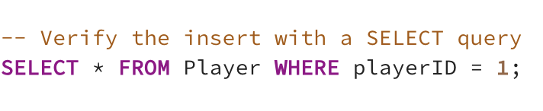

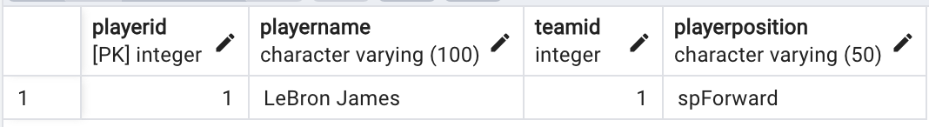

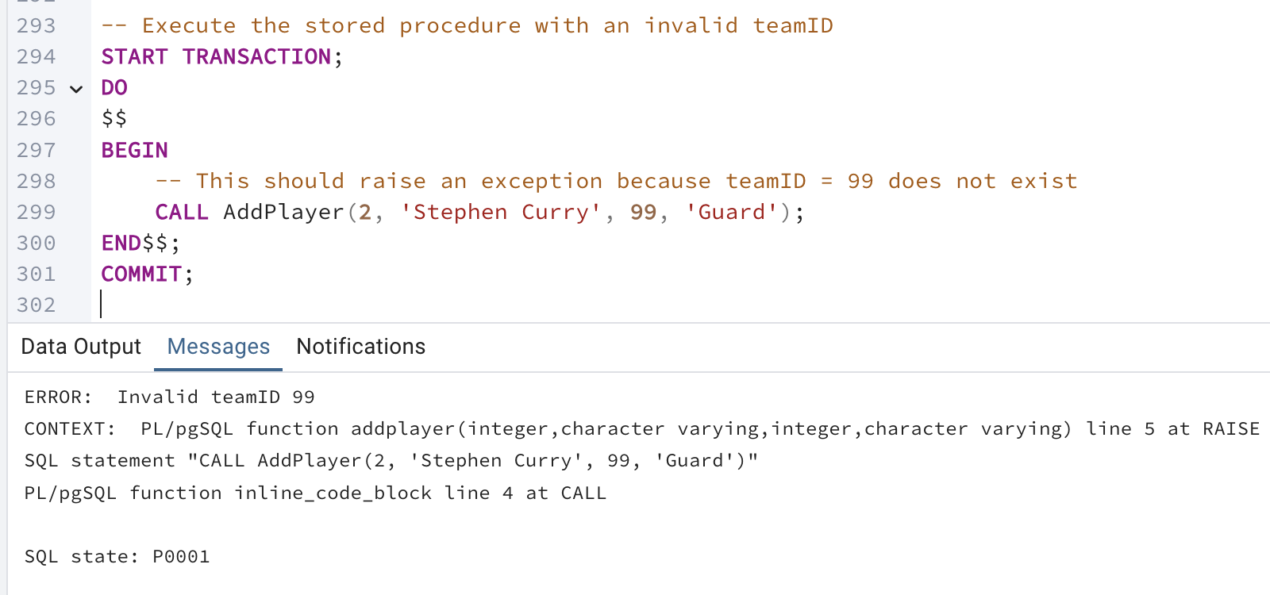

This procedure allows for adding a new player to the Player table in a consistent manner. The transaction ensures atomicity, meaning the operation will either fully succeed or fully fail, maintaining data integrity.

2. Procedure to Add a New Team

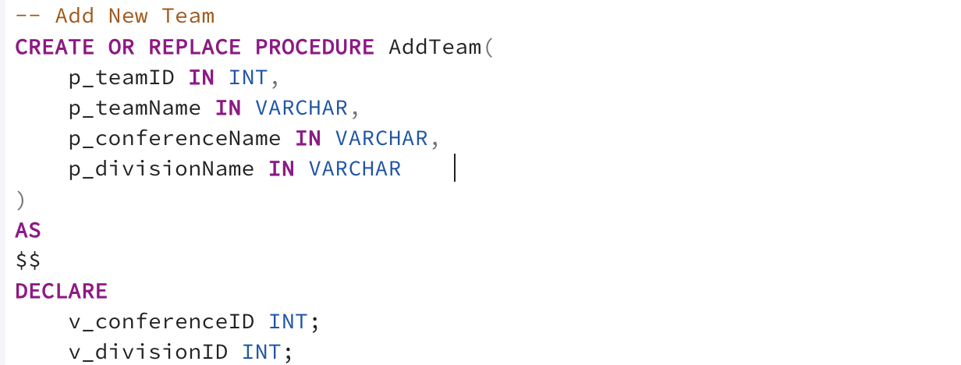

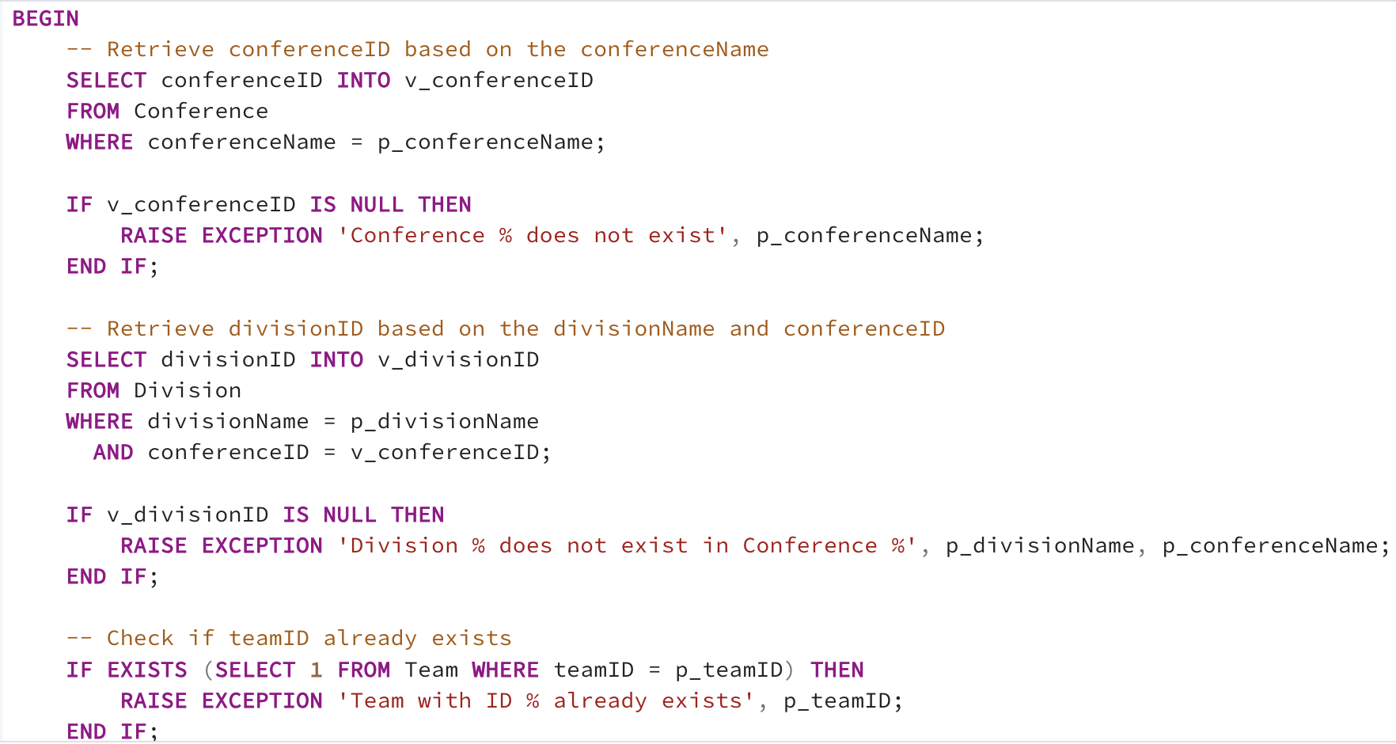

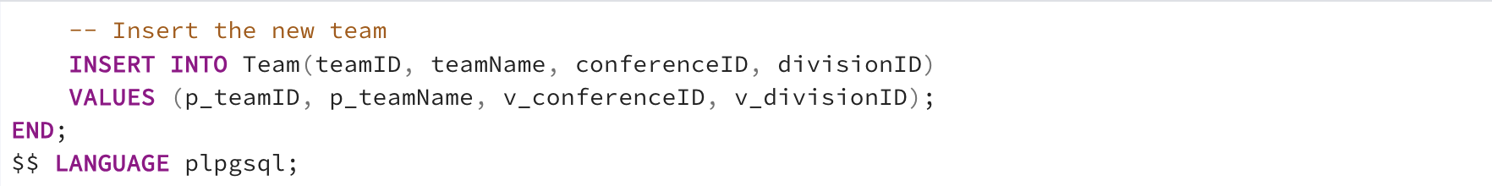

EXAMPLE:  
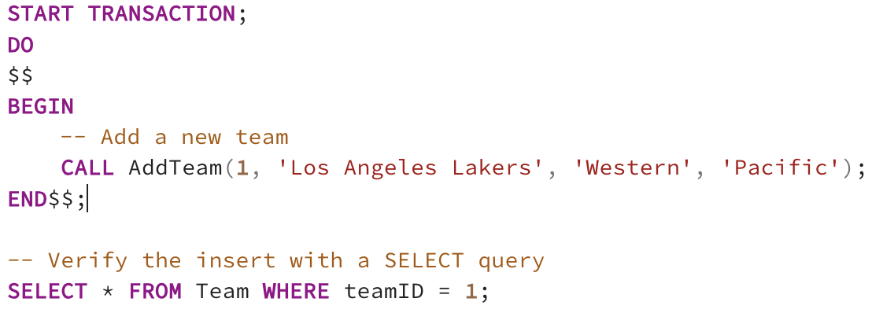

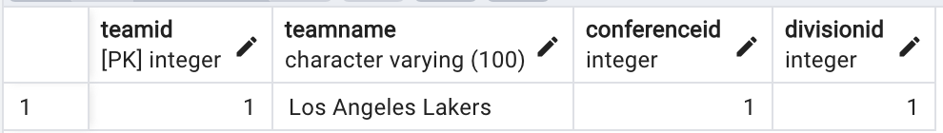  
This procedure ensures that teams are added consistently to the Team table. It helps maintain the integrity of the data by ensuring all required fields are provided and correctly formatted. The use of transactions ensures that the insertion is completed fully or not at all, preventing partial data from being inserted.

3. Procedure to Add a New Game

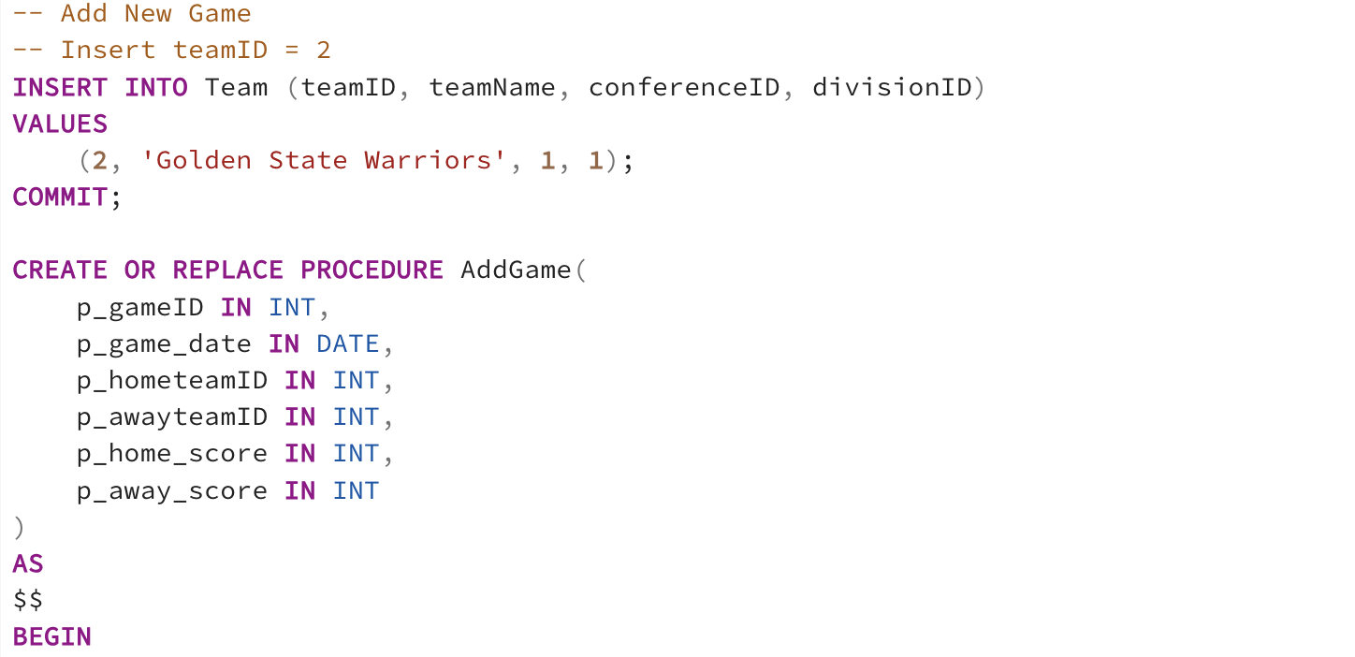

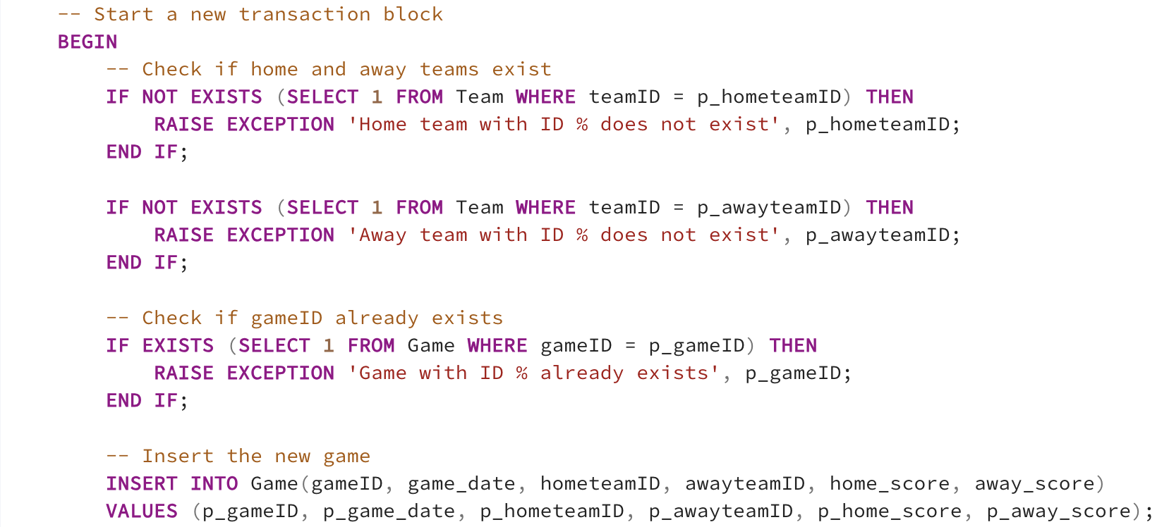

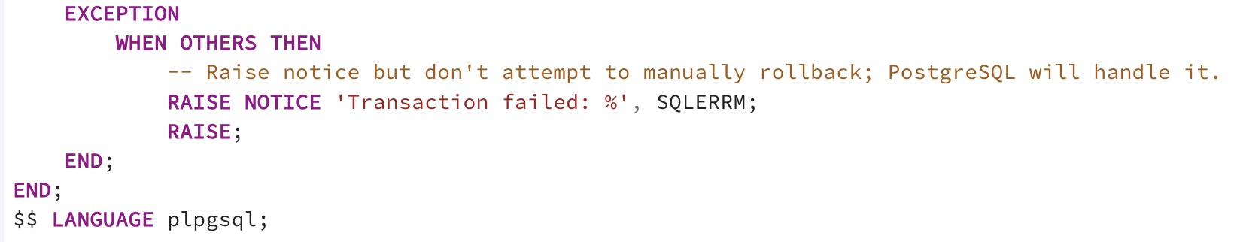

EXAMPLE:

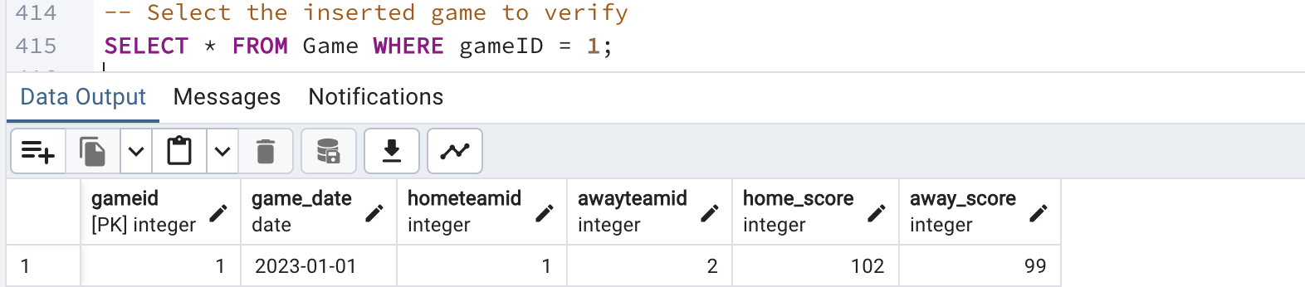

ERROR CHECK:

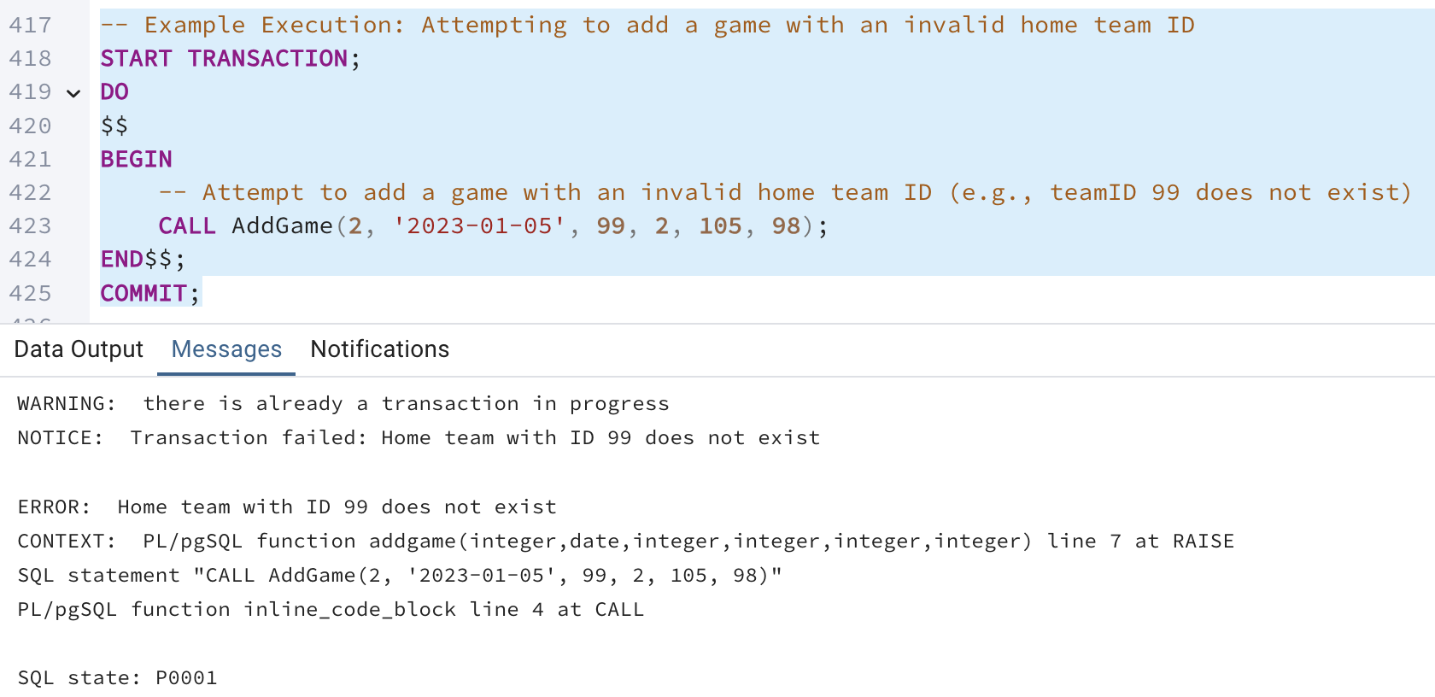

This procedure allows for the addition of new games to the Game table. It ensures that all necessary details about the game are included and correctly formatted. Using a transaction ensures that the game is either fully added or not added at all, maintaining the consistency of the data.

4. Procedure to Add a New Contract

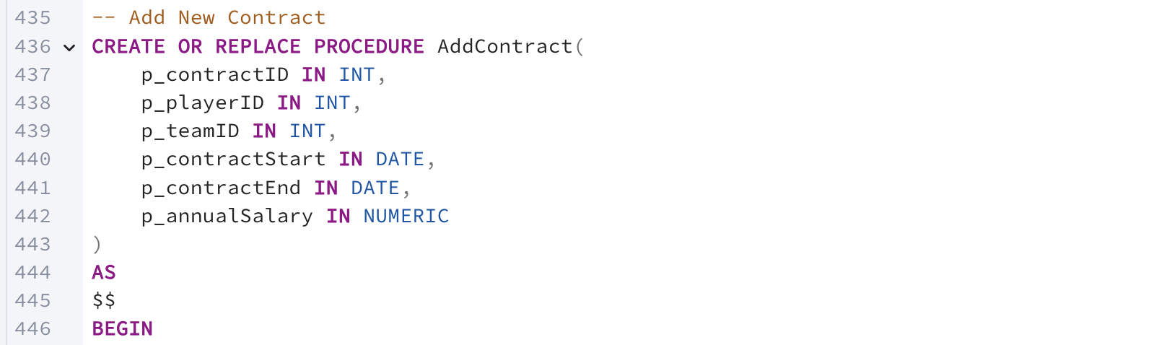

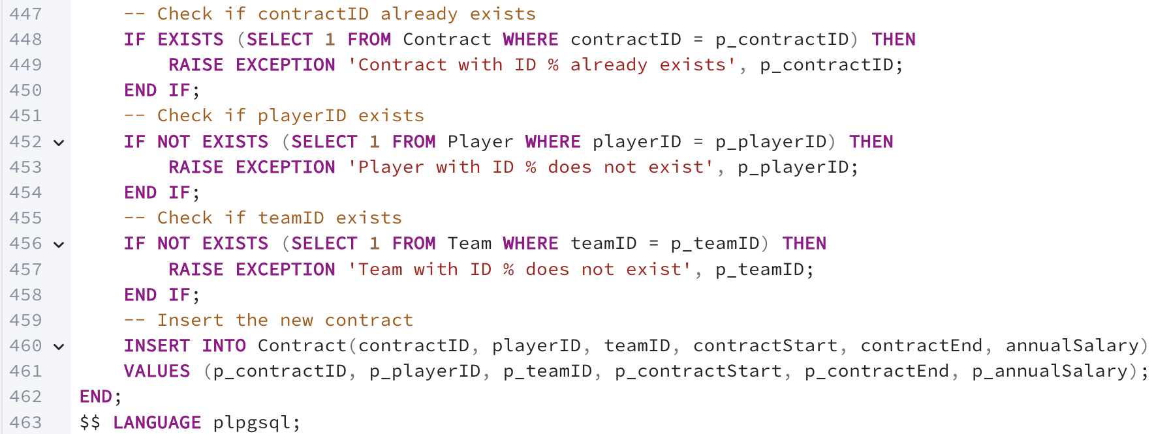

EXAMPLE:

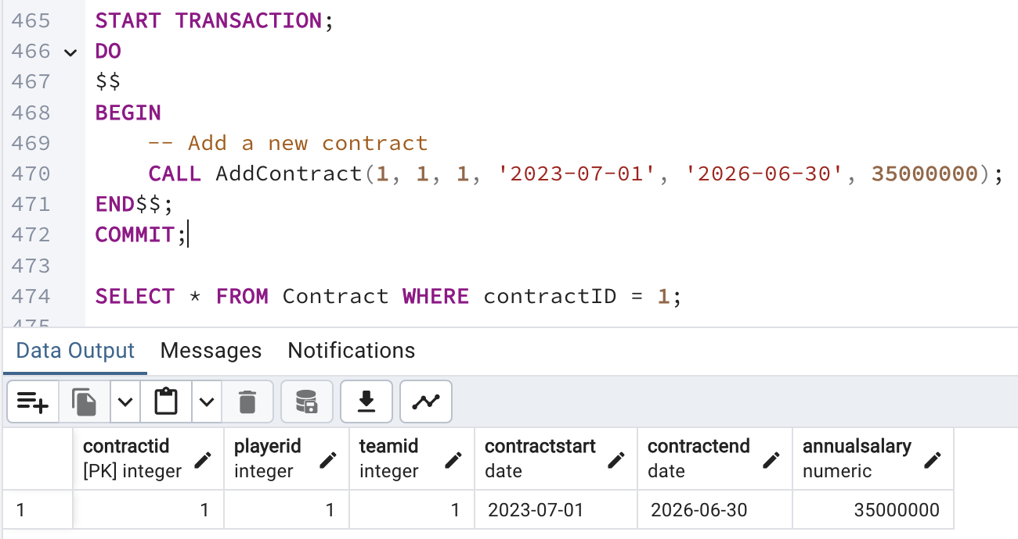

This procedure adds a new contract to the Contract table. It ensures that all necessary details of the contract are included and correctly formatted. The transaction ensures that the insertion is completed fully or not at all, maintaining data integrity.

# Question Identification and Explanations

*Replace this with questions useful to the organization and explanations as to why they are useful.*

1. What is the average points scored by each player?

This query calculates the average points scored by each player, providing insight into their scoring performance over time. It also filters for player averaging more than 15 points.

2. Which team has the highest average points per game?

This query identifies the team with the highest average points per game, which can indicate the most offensively strong team.

3. List all injuries for a specific player.

This query lists all injuries for a specific player, identified by playerID.

4. What are the total rebounds for each team in a specific season?

This query calculates the total rebounds for each team in a specific season.

5. Which players have the highest free throw percentage (FT%) in a specific season?

This query identifies the players with the highest average free throw percentage (FT%) in a specific season.

# Query Executions and Explanations

1.

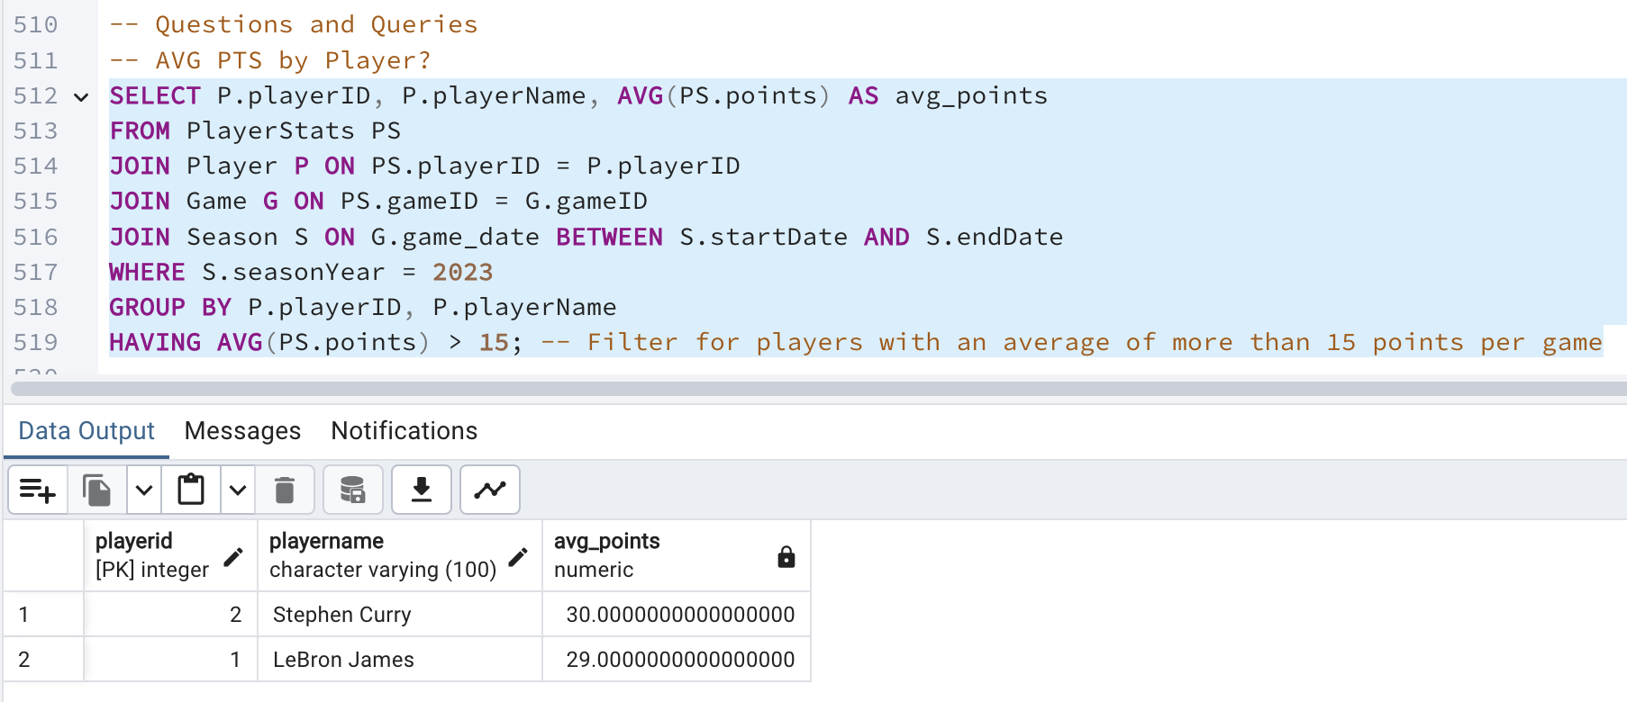

Grouping by playerID ensures that the average is calculated for each individual player, which is useful for performance analysis

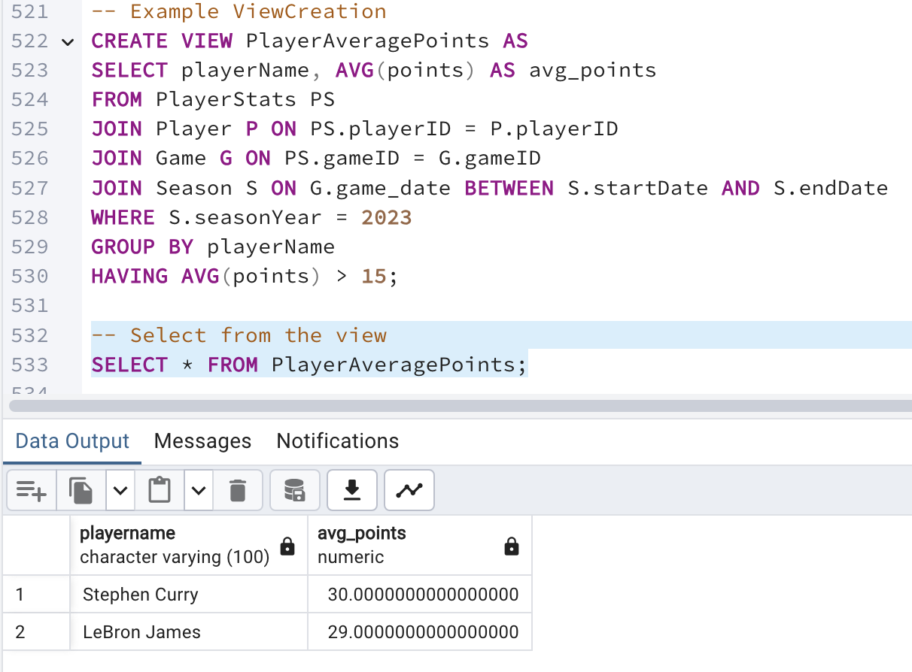

2.

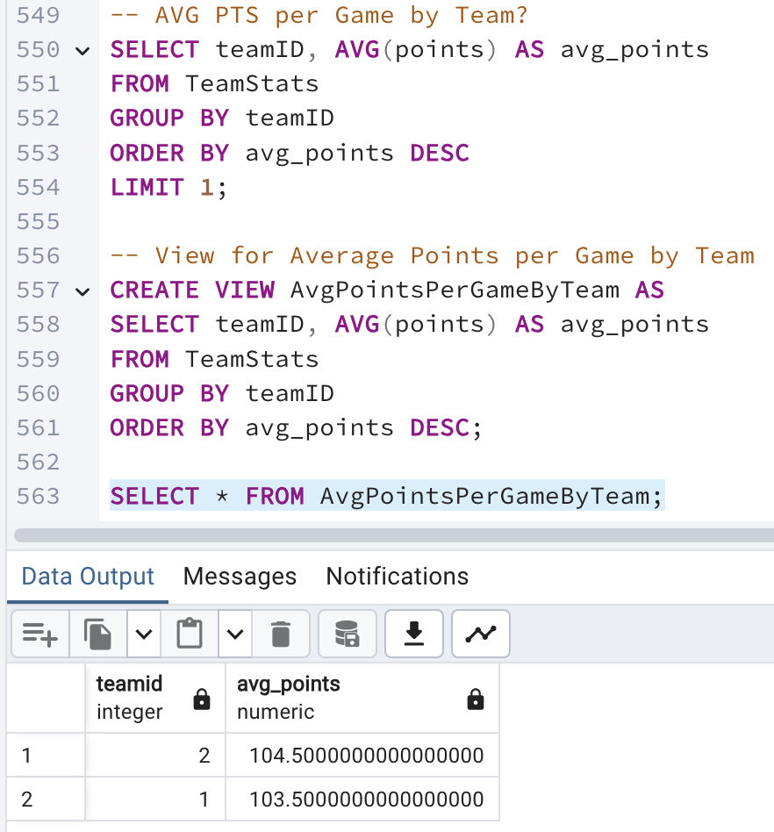

Ordering by average points in descending order and limiting the result to one ensures that only the top-performing team is returned.

3.

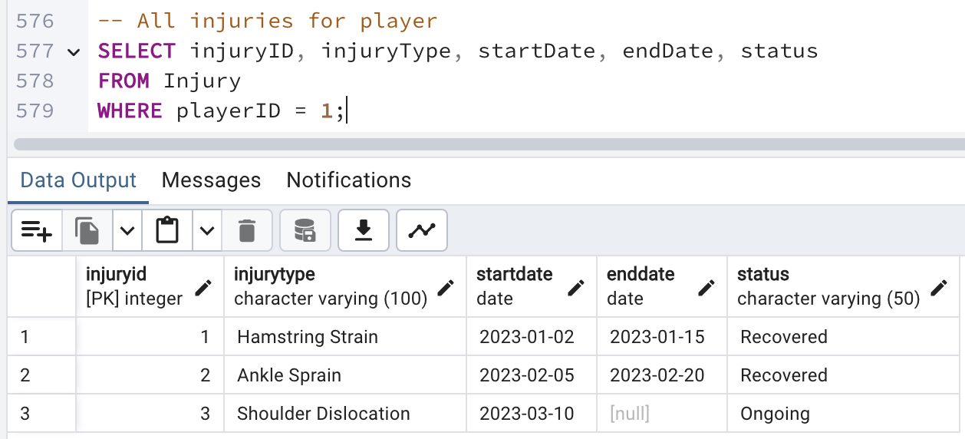

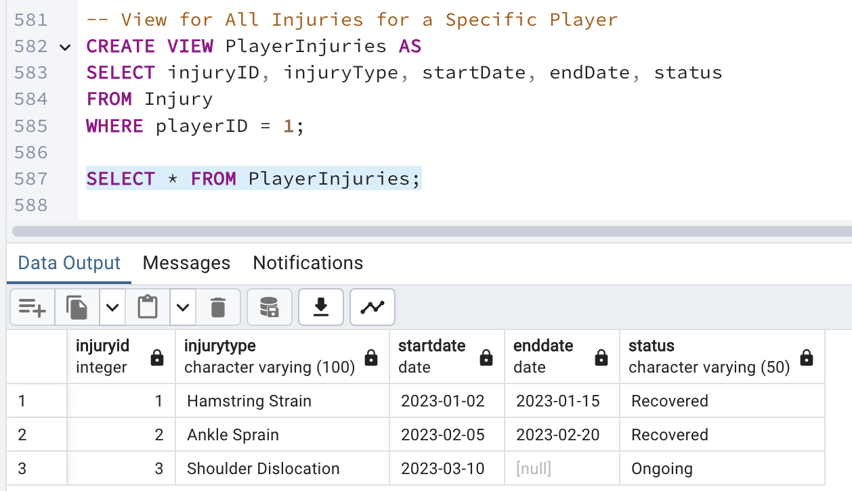

It provides detailed information about each injury, which is useful for tracking the player's health and availability.

4.

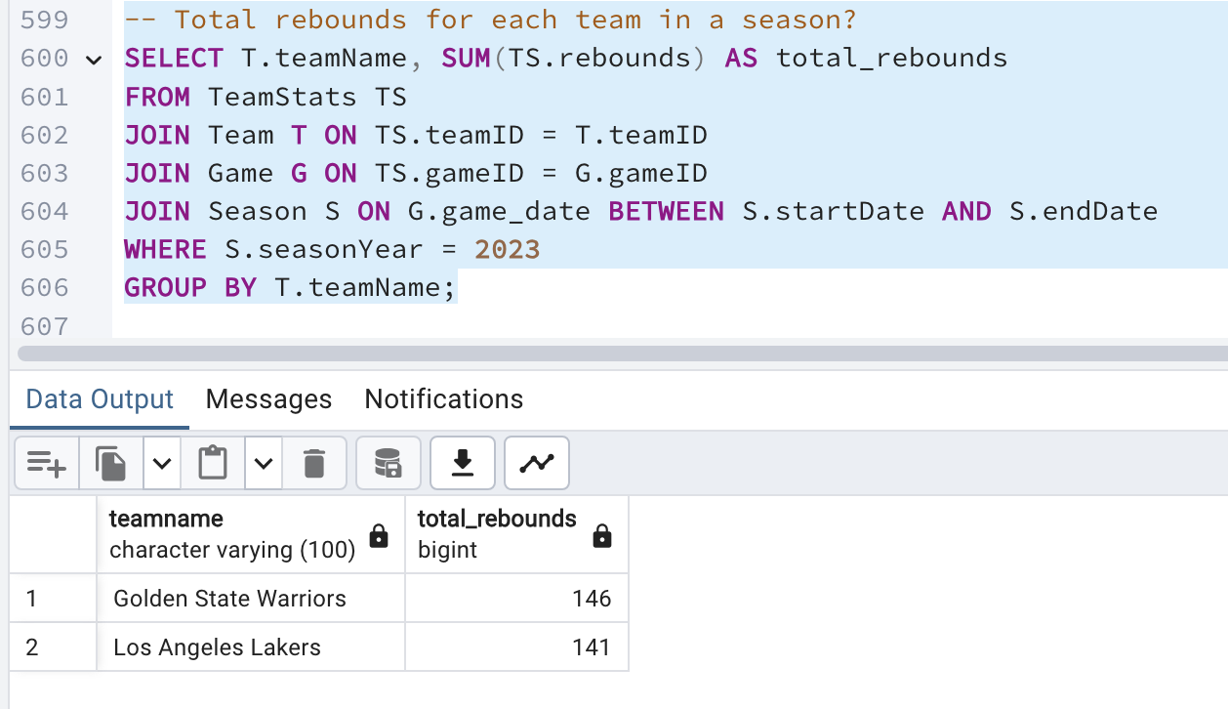

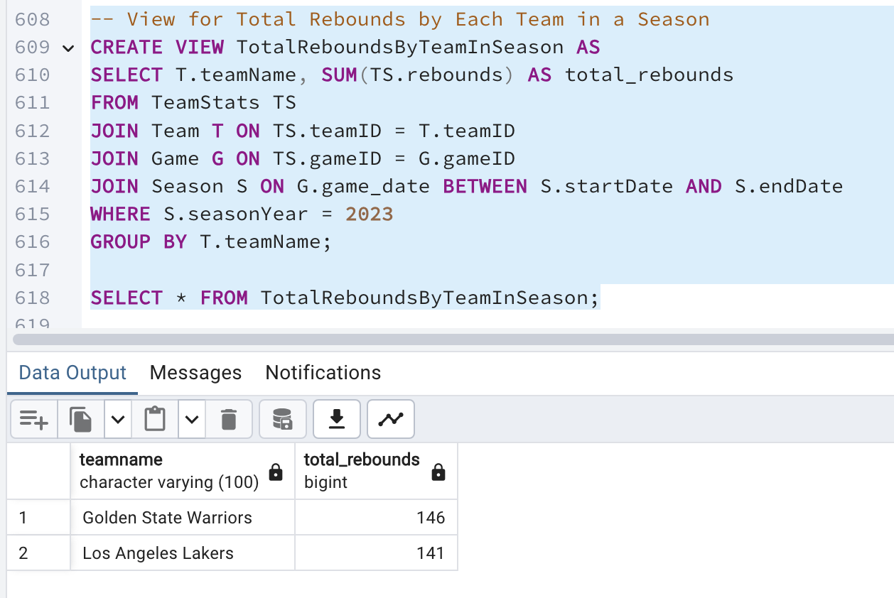Joins the TeamStats, Team, Game, and Season tables to aggregate rebounds by team for the given season. Grouping by teamName ensures that the total rebounds are calculated for each team, providing insights into team performance.

5.

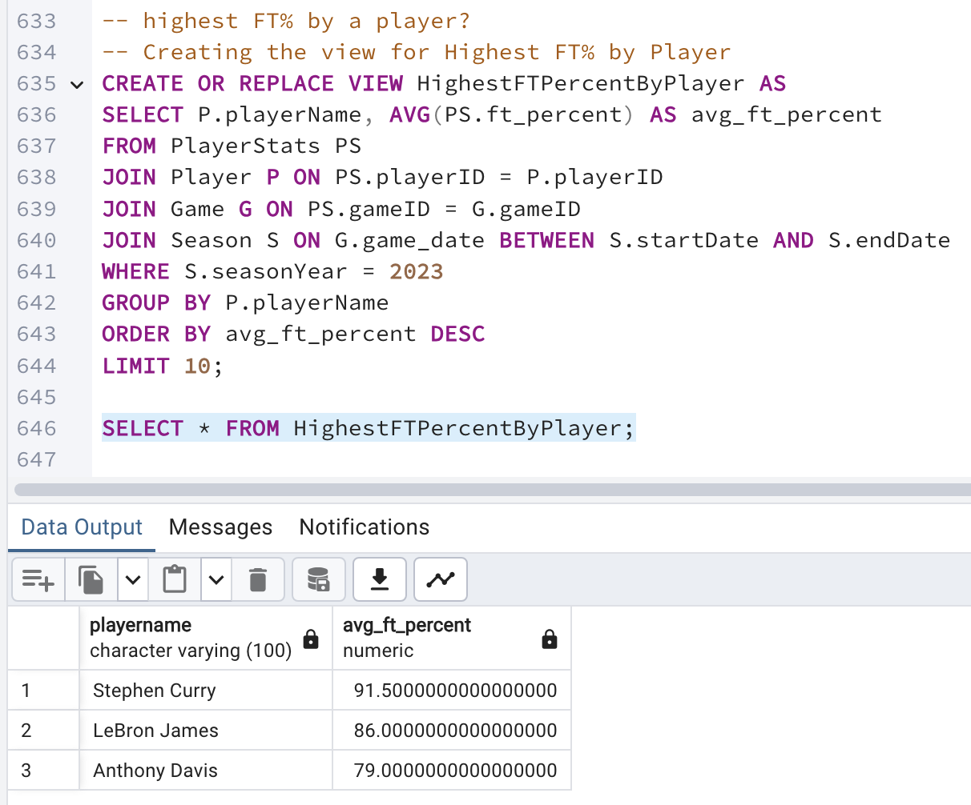

Joins the PlayerStats, Player, Game, and Season tables to calculate the average FT% for each player. Grouping by playerName ensures that the average FT% is calculated for each player, providing insights into player performance. Limiting the results to the top 10 ensures that only the best performers are returned.

# Index Identification and Creations

*Replace this with indexes identifications useful to your database, explanations as to why they help, and screenshots of their creations.*

1. Player Table: Index on teamID to speed up queries filtering by team.

Indexing teamID in the Player table speeds up queries that filter players by their team, which is a common operation when analyzing team rosters and performance.

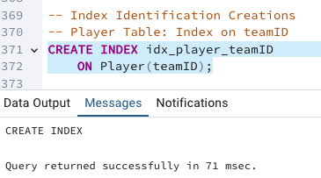

2. PlayerStats Table: Index on playerID and gameID to speed up queries involving player statistics.

Indexing playerID and gameID in the PlayerStats table speeds up queries that involve player performance in specific games, which is essential for detailed performance analysis.

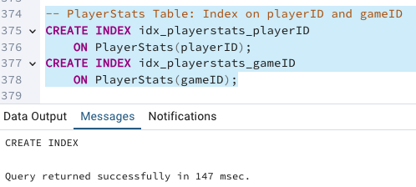

3. TeamStats Table: Index on teamID and gameID to speed up queries involving team statistics.

Indexing teamID and gameID in the TeamStats table speeds up queries that involve team performance in specific games, which is crucial for analyzing team statistics and performance trends.

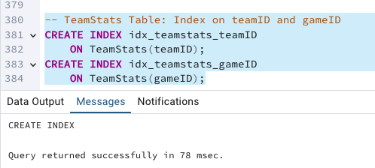

4. Injury Table: Index on playerID to speed up queries involving player injuries.

Indexing playerID in the Injury table speeds up queries that filter injuries by player, which is important for tracking the health and availability of players.

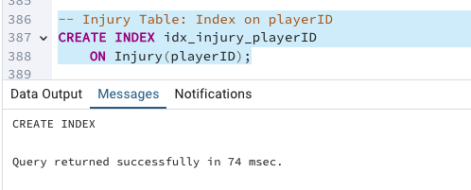

5. Index on seasonYear in the Season Table

Indexing seasonYear in the Season table speeds up queries that filter by season year, which is a common operation when analyzing data for specific seasons. This index improves the performance of queries that retrieve season-specific data.

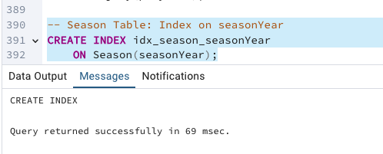

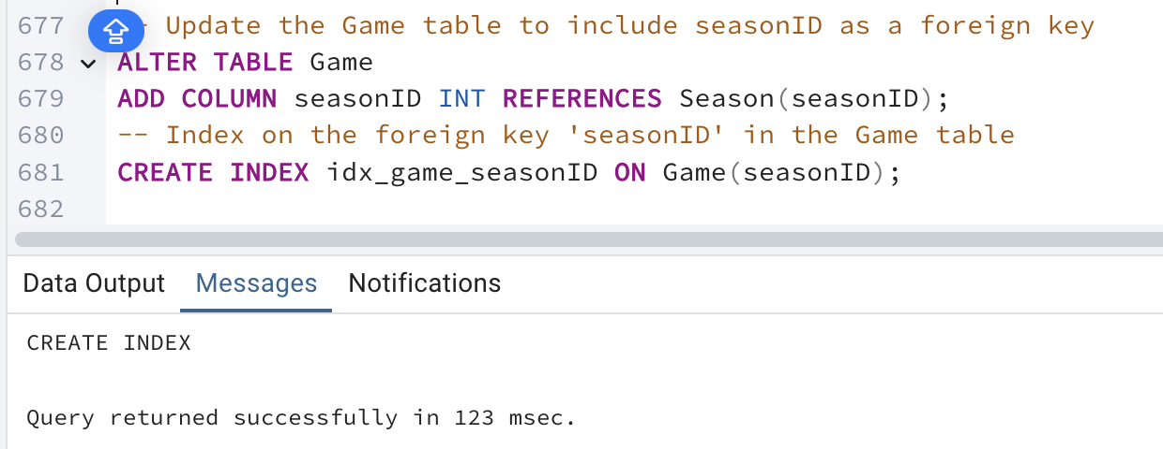

PRIMARY KEY:

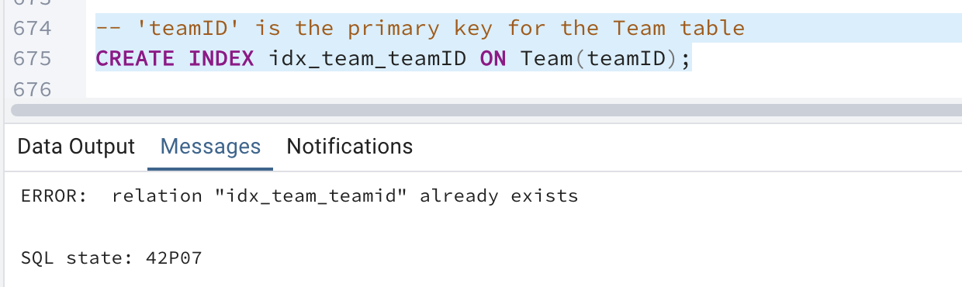

FOREIGN KEYS CREATION:

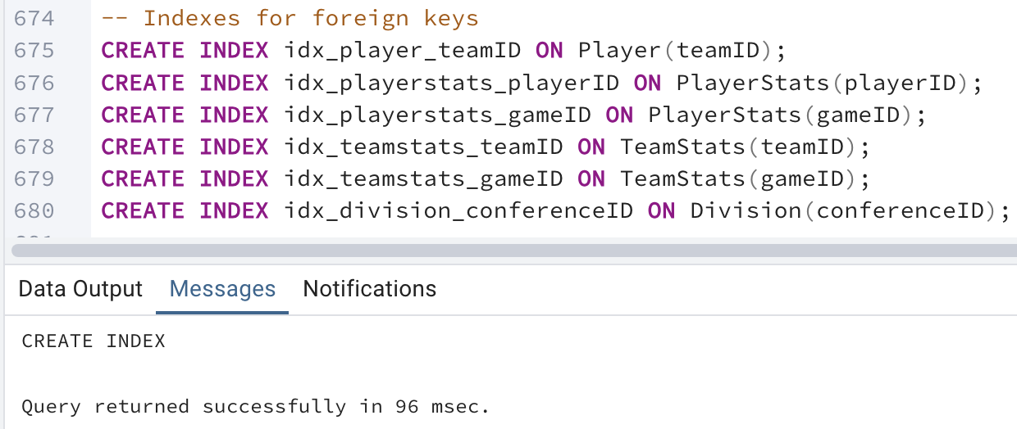

# History Table Demonstration

Create the PlayerInjuryHistory Table

This table will track changes to player injuries, including the impact of injuries on performance and the recovery timeline.

* injuryHistoryID: A unique identifier for each record in the injury history.
* playerID: References the Player table to link the history to the specific player.
* injuryID: References the Injury table to link the history to the specific injury.
* recoveryID: References the Recovery table to link the history to the specific recovery event.
* impactOnPerformance: Describes how the injury impacted the player's performance.
* recoveryDuration: The actual time it took for the player to recover from the injury.
* performanceAfterRecovery: A description or metric of the player's performance post-recovery.
* recordedOn: Timestamp for when the injury history was recorded.

CODE:

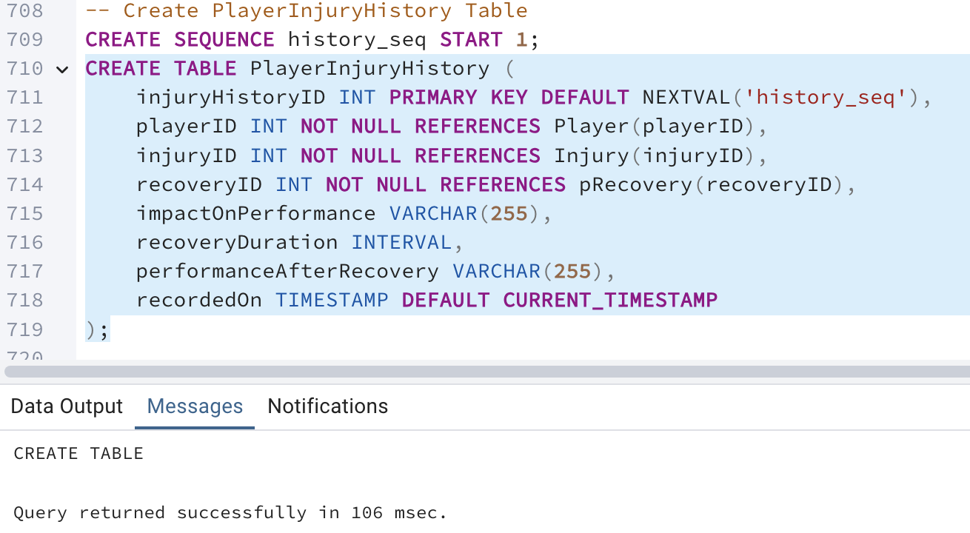

Trigger to Track Injury History

* Trigger will automatically create a record in the PlayerInjuryHistory table whenever an injury is marked as recovered.
* Trigger Function: track_player_injury_history() inserts a new record into PlayerInjuryHistory whenever a player's recovery status is updated to "Recovered."
* Trigger: trg_player_injury_history ensures that the function runs after each update to the Recovery table where the status becomes "Recovered."

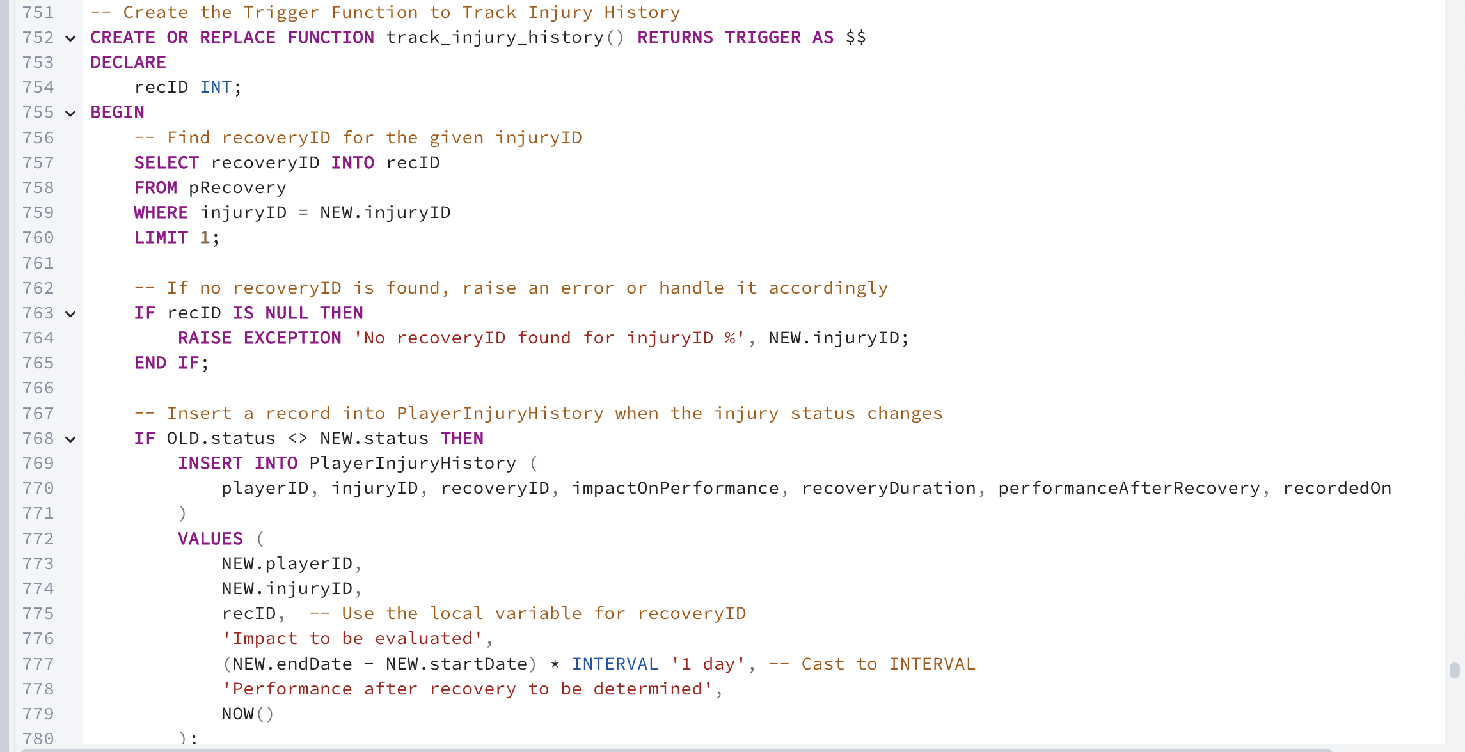



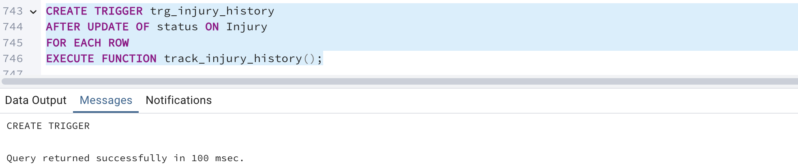

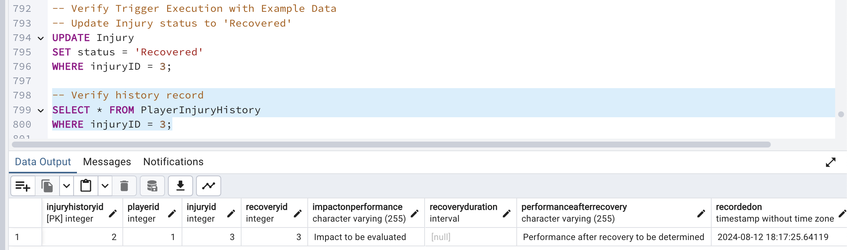

Update 2

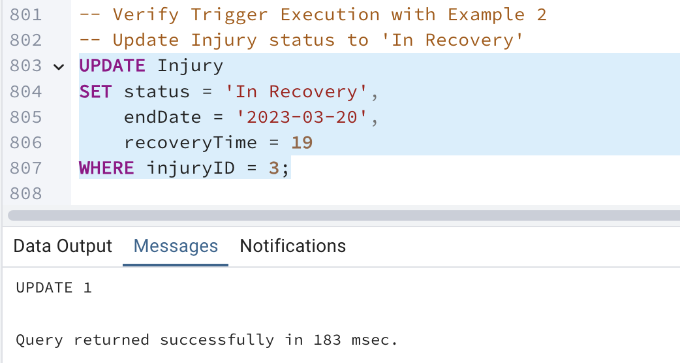

Update 3  
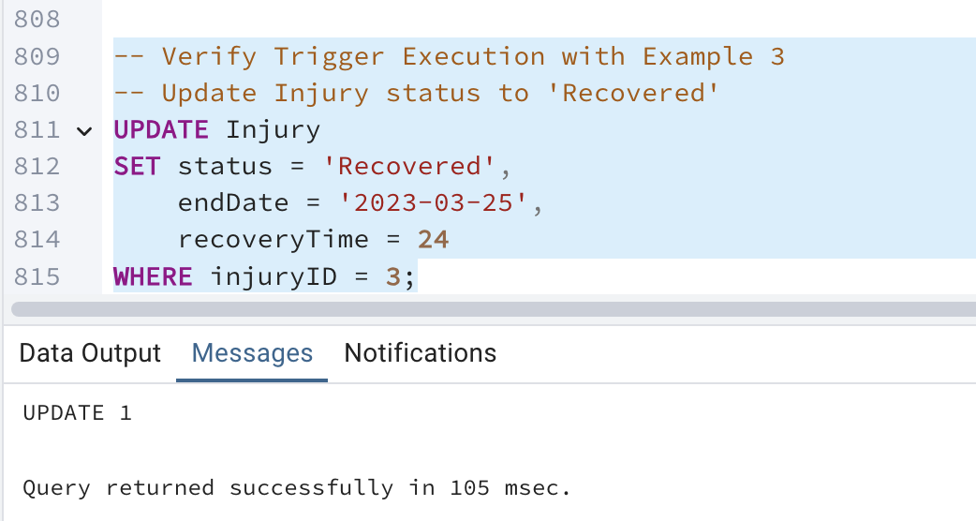

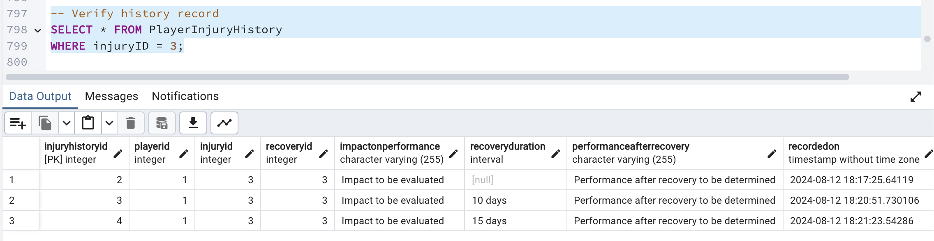

SQL Queries for Injury History

* Query 1: Retrieve All Injury History for a Specific Player
  + Purpose: This query retrieves the complete injury history for a specific player, showing the types of injuries, recovery times, and impact on performance.

Code:

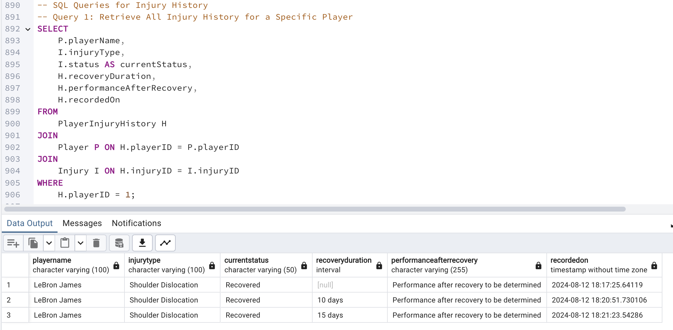

* Query 2: Analyze Recovery Times and Performance Impact Across All Players
  + Purpose: This query provides insights into average recovery times and the average impact on player performance for different types of injuries.

CODE:

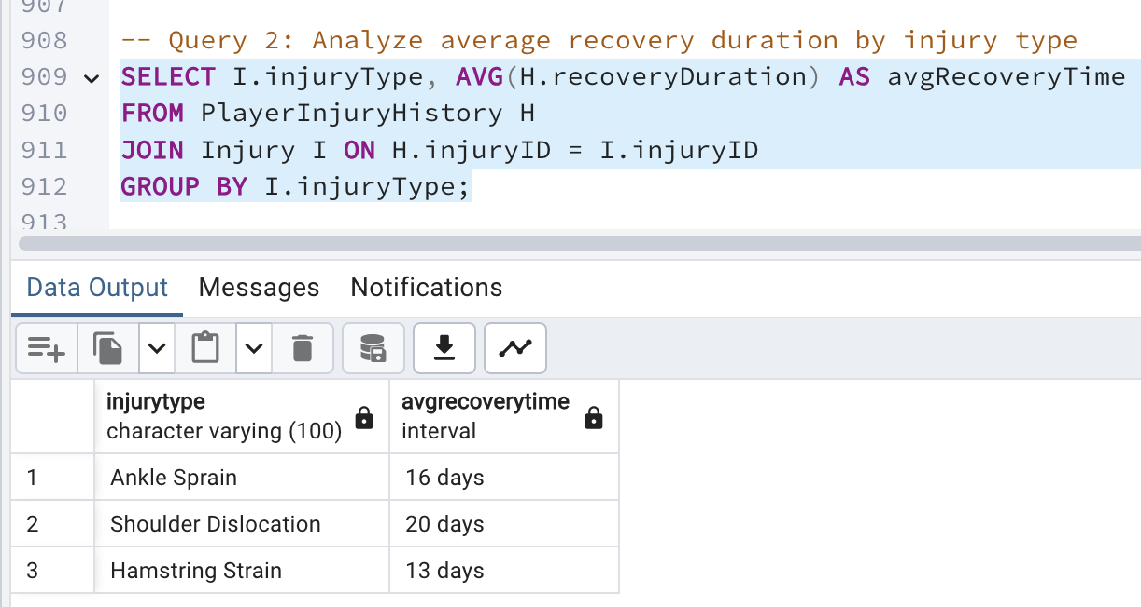

* Query 3: Count of Injuries by Type
  + Purpose: This query provides insights into the different types of injuries.

Code:

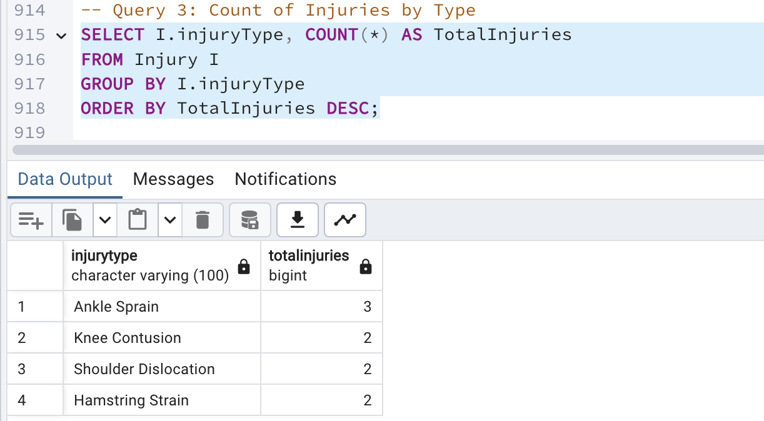

WHY INJURY HISTORY TABLE?

1. Detailed Injury Tracking:

InjuryHistoryID provides a unique identifier for each record, ensuring that every injury event, no matter how minor or significant, is logged and can be referenced individually.

By linking to specific playerID, injuryID, and recoveryID, this table ensures that all aspects of an injury—who it affected, what the injury was, and how recovery was managed—are clearly documented.

2. Analyzing the Impact on Performance:

The impactOnPerformance and performanceAfterRecovery fields allow for the tracking of how injuries affect a player's ability to perform both during and after recovery. This is crucial for understanding the long-term effects of injuries on a player's career and performance.

3. Recovery Insights:

The recoveryDuration field provides valuable data on how long it takes to recover from specific injuries, which can be used to improve medical and training staff's understanding of recovery timelines. This can help in setting more accurate expectations for return-to-play and managing player rotations.

4. Historical Data for Predictive Analysis:

Having a comprehensive history of injuries, including how players recover and perform afterward, allows teams to perform predictive analysis. They can identify trends, such as whether certain injuries tend to reoccur or whether certain players are prone to longer recovery times, and adjust their training or medical interventions accordingly.

# Data Visualizations

Visualization 1: Average Recovery Duration by Injury Type

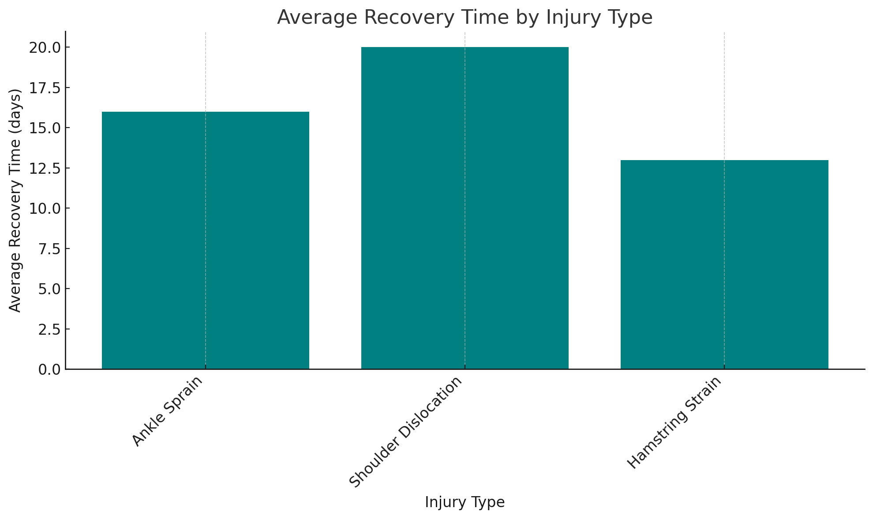

Bar Chart: Average recovery duration on the y-axis, injury types on the x-axis.

Insights from the Bar Chart:

Variation in Recovery Times Across Injuries: The first observation is that there is a noticeable variation in average recovery times among different injury types. For example, a Shoulder Dislocation has the longest average recovery time at 20 days, whereas a Hamstring Strain takes an average of 13 days. This suggests that shoulder injuries might be more severe or require more extensive rehabilitation compared to other types.

Impact on Player Availability: The second insight is that the recovery time directly impacts player availability and team performance. Injuries like Ankle Sprains and Hamstring Strains with relatively shorter recovery times might allow players to return to play more quickly, whereas injuries like Shoulder Dislocations could lead to longer absences. This information is crucial for coaches and medical staff when planning player rotations and rehabilitation strategies.

Focus on Shoulder Injuries: The longer recovery time for shoulder dislocations raises a red flag and might require deeper investigation. Teams may need to consider special training, prevention strategies, or even player-specific care to mitigate the impact of such injuries. Understanding why shoulder injuries take longer to heal could lead to improvements in treatment protocols.

Data Story for Visualization 2:

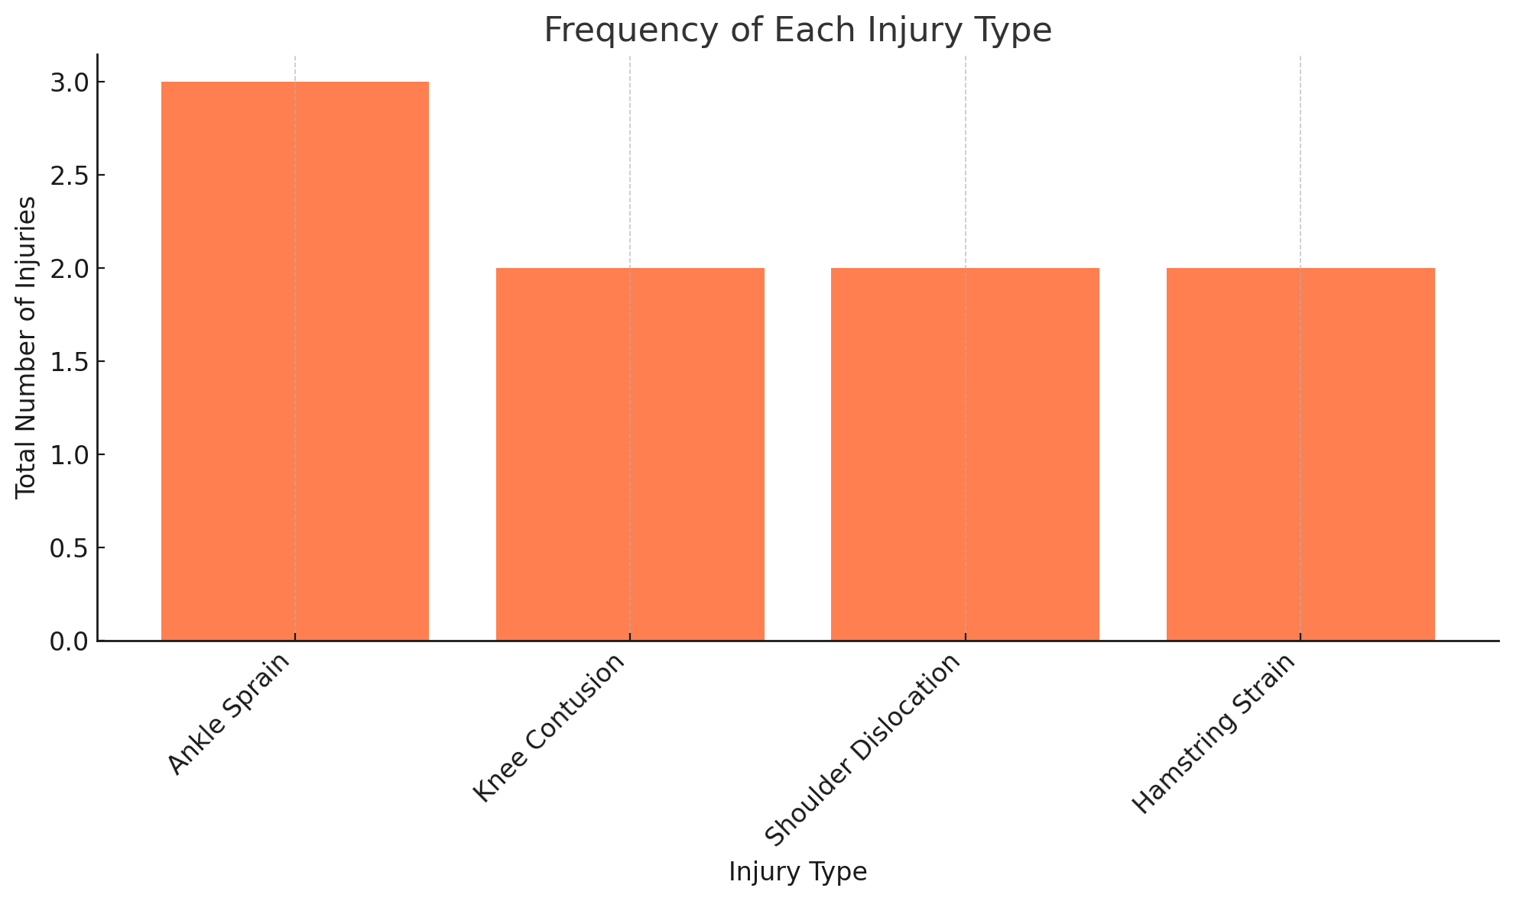

Bar chart: visualizes the total number of injuries for each injury type

Ankle Sprains are the Most Common Injury: The first observation is that Ankle Sprains are the most frequent injury, with three recorded instances. This suggests that ankle injuries might be a prevalent issue among players, possibly due to the demands of their sport, which might involve frequent cutting, jumping, or sudden direction changes.

Uniformity in Other Injuries: The other injuries—Knee Contusion, Shoulder Dislocation, and Hamstring Strain—each have two recorded instances. This indicates a relatively even distribution of these types of injuries, showing that while they are less common than ankle sprains, they still occur with notable frequency.

Focus on Ankle Injury Prevention: Given that ankle sprains are the most common injury, there may be an opportunity to focus more on injury prevention in this area. This could involve targeted exercises, better footwear, or more robust warm-up routines to reduce the incidence of ankle injuries.

# Summary and Reflection

#### Project Summary:

My database is for an NBA Analytics Platform that leverages NBA data to provide detailed insights. The platform integrates various data sources, including official NBA statistics and player performance metrics, into a cohesive system for analysis. It supports tracking and analyzing player statistics, team performance, historical game results, and advanced metrics. The structural database rules and conceptual ERD for the database design include the important entities of Player, Team, Contract, Season, SalaryCap, Game, PlayerStats, TeamStats, Injury, and Recovery, as well as the relationships between them. The design incorporates specialization-generalization hierarchies to reflect the different roles and attributes within these entities.

For instance:

* Contract can be specialized into RookieContract, VeteranContract, MaxContract, and FreeAgentContract.
* Injury can be specialized into MinorInjury and MajorInjury.
* Game can be specialized into RegularSeasonGame, PlayoffGame, and ExhibitionGame.

#### Work Improvements from previous iterations:

* Iteration 4
  + The EERD subtype notation was successfully replaced with the Crow's foot 1:1 notation, ensuring a more accurate physical model representation.
  + The normalization of Conference and Division was implemented to reduce redundancy, creating separate tables for these attributes and linking them via foreign keys.
  + Subtype tables were evaluated, and those without significant differences were removed to reduce complexity
* Iteration 5
  + Stored procedure execution was enhanced by adding SELECT statements after each execution to verify that the inserts were performed correctly.
  + Error handling was added to manage scenarios where an invalid team ID or other invalid data is passed in, preventing potential issues during data manipulation.
  + Filters were added to queries to prevent large and unwieldy result sets, ensuring that the data returned is both relevant and manageable.
  + Queries were implemented as views where appropriate, improving reusability and maintainability.
  + Index identification was enhanced by explicitly listing the primary and foreign key columns, ensuring that these crucial columns are indexed to optimize query performance.

#### Work Completed:

#### A detailed conceptual ERD visualizing the structural database rules, entities, relationships, and specialization-generalization hierarchies.

#### All tables normalized to BCNF, reducing redundancy and improving data integrity.

#### A full DBMS physical ERD with attributes, including primary keys, foreign keys, and other necessary fields.

#### SQL DDL statements for creating tables, sequences, and constraints based on the DBMS physical ERD.

#### Corrected SQL syntax errors related to reserved keywords such as position, location, and date by renaming parameters in stored procedures to playerPosition, gameLocation, and gameDate, respectively.

#### Created reusable stored procedures for adding records to the Player, Team, Game, and Contract tables, including enhanced error handling to manage duplicates and invalid entries.

#### Executed complex queries to retrieve meaningful insights from the database, such as average player points, team performances, and player free throw percentages.

#### Implemented history tracking for injuries using a trigger to log changes in injury status, adding valuable historical context to player performance analysis.

#### Added new data for player injuries and recoveries to enhance the accuracy and usefulness of injury-related queries.

#### Concerns:

#### Managing the large volume of NBA data for a single season, including real-time updates and off-season changes, remains complex.

#### Ensuring data integrity and consistency across multiple related tables with complex relationships and foreign key constraints is crucial.

#### Questions:

* What strategies can be employed to ensure efficient data entry and updates while maintaining database performance?
* What indexing, query optimization, and data retrieval techniques can be employed to ensure optimal database performance?

#### Reflection:

# This week involved significant progress in troubleshooting and input data, particularly around managing injuries and performance metrics. We focused on enhancing error handling and ensuring the database structure supports efficient data retrieval and analysis. However, dependencies and data population remain critical areas to address in the future work.

# Appendix (supporting material)

1. Player

Attributes:

playerID: Unique identifier for each player, set as the primary key.

playerName: Full name of the player.

teamID: Foreign key referencing the Team table to associate a player with a specific team.

position: Position the player plays (e.g., Guard, Forward, Center).

Specializations:

Players can be specialized into Guard, Forward, Center, StartingPlayer, and BenchPlayer.

This helps in categorizing players based on their playing positions and roles within the team.

2. Team

Attributes:

teamID: Unique identifier for each team, set as the primary key.

teamName: Name of the team.

conference: Conference the team belongs to.

division: Division the team belongs to.

Relationships:

One-to-Many relationship with Player (A team has many players).

Many-to-Many relationship with Season via TeamSeason (A team participates in many seasons).

3. Contract

Attributes:

contractID: Unique identifier for each contract, set as the primary key.

playerID: Foreign key referencing the Player table to associate a contract with a specific player.

teamID: Foreign key referencing the Team table to associate a contract with a specific team.

contractStart: Start date of the contract.

contractEnd: End date of the contract.

annualSalary: Annual salary specified in the contract.

Specializations:

Contracts can be specialized into RookieContract, VeteranContract, MaxContract, and FreeAgentContract.

This helps in categorizing contracts based on their types and specific provisions.

4. Season

Attributes:

seasonID: Unique identifier for each season, set as the primary key.

seasonYear: Year of the season.

Relationships:

One-to-One relationship with SalaryCap (Each season has one salary cap).

Many-to-Many relationship with Team via TeamSeason (A season involves many teams).

5. SalaryCap

Attributes:

capID: Unique identifier for each salary cap, set as the primary key.

seasonID: Foreign key referencing the Season table to associate a salary cap with a specific season.

salaryCap: Salary cap amount for the season.

firstApron: First apron amount.

secondApron: Second apron amount.

6. Game

Attributes:

gameID: Unique identifier for each game, set as the primary key.

date: Date on which the game was played.

hometeamID: Foreign key referencing the Team table to associate the home team with the game.

awayteamID: Foreign key referencing the Team table to associate the away team with the game.

home_score: Points scored by the home team.

away_score: Points scored by the away team.

Specializations: (potential specialization?)

Games can be specialized into RegularSeasonGame, PlayoffGame, and ExhibitionGame.

This helps in categorizing games based on their types and significance.

7. PlayerStats

Attributes:

playerID: Foreign key referencing the Player table to associate player stats with a specific player.

gameID: Foreign key referencing the Game table to associate player stats with a specific game.

points: Points scored by the player.

rebounds: Rebounds made by the player.

assists: Assists made by the player.

steals: Steals made by the player.

blocks: Blocks made by the player.

turnovers: Turnovers made by the player.

ft_percent: Free throw percentage of the player.

fg_percent: Field goal percentage of the player.

three_points: Three-pointers made by the player.

Relationships:

One-to-Many relationship with Player (A player has many player stats entries).

One-to-Many relationship with Game (A game has many player stats entries).

8. TeamStats

Attributes:

teamID: Foreign key referencing the Team table to associate team stats with a specific team.

gameID: Foreign key referencing the Game table to associate team stats with a specific game.

points: Points scored by the team.

rebounds: Rebounds made by the team.

assists: Assists made by the team.

steals: Steals made by the team.

blocks: Blocks made by the team.

turnovers: Turnovers made by the team.

ft_percent: Free throw percentage of the team.

fg_percent: Field goal percentage of the team.

three_points: Three-pointers made by the team.

Relationships:

One-to-Many relationship with Team (A team has many team stats entries).

One-to-Many relationship with Game (A game has many team stats entries).

9. Injury

Attributes:

injuryID: Unique identifier for each injury, set as the primary key.

playerID: Foreign key referencing the Player table to associate an injury with a specific player.

gameID: Foreign key referencing the Game table to associate an injury with a specific game.

injuryType: Type of the injury (e.g., sprain, fracture).

startDate: Date when the injury was first recorded.

endDate: Date when the injury was resolved or expected to resolve.

status: Current status of the injury (e.g., day-to-day, out, questionable).

recoveryTime: Estimated recovery time for the injury.

Specializations:

Injuries can be specialized into MinorInjury and MajorInjury.

This helps in categorizing injuries based on their severity.

10. Recovery

Attributes:

recoveryID: Unique identifier for each recovery, set as the primary key.

injuryID: Foreign key referencing the Injury table to associate a recovery with a specific injury.

startDate: Date when the recovery started.

endDate: Date when the recovery ended.

status: Current status of the recovery.

11. TeamSeason (Junction Table)

Attributes:

teamID: Foreign key referencing the Team table to associate a team with a specific season.

seasonID: Foreign key referencing the Season table to associate a season with a specific team.

Primary Key: (teamID, seasonID)

Relationships:

Many-to-Many relationship between Team and Season.

|  |  |  |  |  |  |
| --- | --- | --- | --- | --- | --- |
| Relationships | | | | | |
| Team to Player | | | Player to Injury | | |
| Relationship | Cardinality | Why it's Needed | Relationship | Cardinality | Why it's Needed |
| Team has Players | One-to-Many | A team has many players; a player belongs to one team. | Player has Injuries | One-to-Many | A player has many injuries; an injury is associated with one player. |
| Player to Contract | | | Injury to Recovery | | |
| Relationship | Cardinality | Why it's Needed | Relationship | Cardinality | Why it's Needed |
| Player has Contract | One-to-One | A player has one contract per team; a contract is associated with one player. | Injury has Recovery | One-to-One | An injury has one recovery; a recovery is associated with one injury. |
| Team to Contract | | | Player has PlayerStats | | |
| Relationship | Cardinality | Why it's Needed | Relationship | Cardinality | Why it's Needed |
| Team has Contracts | One-to-Many | A team has many contracts; a contract is associated with one team. | Player has PlayerStats | One-to-Many | A player has many player stats entries, each associated with different games; player stats provide detailed performance data for each game. |
| Team to Season | | | Game has PlayerStats | | |
| Relationship | Cardinality | Why it's Needed | Relationship | Cardinality | Why it's Needed |
| Team participates in Seasons | Many-to-Many | A team participates in many seasons; a season involves many teams. | Game has PlayerStats | One-to-Many | A game has many player stats entries, one for each player participating in the game; player stats provide detailed performance data for each game. |
| Season to SalaryCap | | | Team has TeamStats | | |
| Relationship | Cardinality | Why it's Needed | Relationship | Cardinality | Why it's Needed |
| Season has SalaryCap | One-to-One | A season has one salary cap; a salary cap is associated with one season. | Team has TeamStats | One-to-Many | A team has many team stats entries, each associated with different games; team stats provide overall performance data for each game. |
| Player to Game | | | Game has TeamStats | | |
| Relationship | Cardinality | Why it's Needed | Relationship | Cardinality | Why it's Needed |
| Player participates in Games | Many-to-Many | A player participates in many games; a game involves many players. | Game has TeamStats | One-to-Many | A game has team stats entries, one for each team participating in the game; team stats provide overall performance data for each game. |
| Team to Game | | |  |  |  |
| Relationship | Cardinality | Why it's Needed |  |  |  |
| Team participates in Games | Many-to-Many | A team participates in many games; a game involves two teams. |  |  |  |